- First Possession

First Possession: used to establish ownership when the thing being claimed is regarded as unowned, being up for grabs

Pierson v. Post → first possession / hunter who trapped fox, D, has possession
- Two people are hunting foxes on common land
- P about to catch a fox after pursuing it for awhile
- D sees P about to catch the fox and jumps in and catches the fox instead
- P does not pass tests for first possession that court establishes
- D passes majority specific rule for trappers → D gets first possession rights to fox
  - Note that just because P does not get the fox does not automatically imply that D gets possession rights to the fox!
Majority
- Motivation → for the sake of certainty and peace in society
  - First possession makes it clear (in theory) who has possession and by making it clear, there is (in theory) less debate
  - Reasoning is purely instrumental → cares about efficiency and predictable outcomes
    - Does not care about what is moral, or who morally deserves the fox
  - Decision should be based on legal theorists and case law

  - General Rule
    - Pursuer is deemed to have possession if he:
      - (1) manifests an unequivocal intention to capture the animal AND
      - (2) has deprived the animal from his natural liberty AND
      - (3) has brought the animal within his certain control
  - “Certain” + “unequivocal” → test reflects the motivations of creating the test
  - It is the pursuers obligation to establish the certainty
  - Easier for pursuer to satisfy than dissent’s rule

  - Specific rule
    - For hunters → mortally wound the animal AND does not abandon pursuit = possession
    - For trappers → using nets or other means of interception, traps the animals so as to deprive them of their natural liberty

Dissent Livingston
  - Motivation → want to encourage fox hunting, they are pests, if we allow people to swoop in and claim foxes that other people worked for, that will disincentivize fox hunting
    - Reasoning is also purely instrumental
  - General Rule
    - Pursuer is deemed to have possession if he:
      - (1) Shows intention to convert the animal to their own use AND
      - (2) the animal is either within reach of the pursuer OR the pursuer has a reasonable prospect of taking it

  - Possession does not require physical possession of the animal
  - This test is easier to satisfy for pursuer → does not require mortal wounding or physical trapping of animal
  - This test is less certain/straightforward than the majority’s rule
    - Recall motivation was not focused on certainty
    - Motivation = incentivizing hunting foxes
  - Recommends institutional competence
    - fox hunter custom should decide what the rule is for possession
    - “Tribunal of sportsmen”
    - Customs are worthy of deference
    - Why does law say what the right answer is here?

Theme Alert
- Should custom or formal law dictate possession law?
  - What is the optimal source of possession law?
    - “First in time” from Pierson
      - Pro: makes it clear who has ownership (theoretically)
      - Con: can create wasteful competitions to be frist, can lead to overexploitation of resources (tragedy of commons)

Ghen v. Rich → custom dictates first possession rule
- Custom in Cape Cod is for whale finders to turn in bodies for finder fee $
- Here whale finder deviates from custom and sells whale body for his own $
  - Applying majority test from Pierson, unclear if whale hunter “abandoned pursuit” due to sink, and float, nature of whale carcass
    - Technical context of first possession is important + influences outcome after applying the legal rule
      - Ex: here, the whalers win in this case, which is opposite of Pierson
      - Harder for the pursuer to prove in the whale-hunting context vs. fox-hunting context
- Holding: we should follow custom here, whale finder did not have possession over whale carcass
  - Following custom did not conflict w/ common law, so it’s consistent
    - However court said even if it does conflict, they found compelling reasons to follow customs!!!!!

  - Does not dangerously influence future law → applies to whaling context only so stakes are low to follow industry custom
    - *Perhaps when setting a broad-applying precedent, industry custom might not be followed*

  - Customs work well, they evolve over time + adopt, are successful
  - Following custom is necessary to incentivize industry to continue
  - Custom seems fair (custom rewards finders $)

Criticisms of following custom for law
- Made by groups that have special interests in mind
  - Can be bias, favor certain groups
  - Groups are often built on structures of inequalities
- Customs might not be socially good
  - Who made custom?
  - Who is benefitting from custom?
- When custom changes, how does law change?
- How does Judge determine what custom is?
- If custom is prevailing over law only sometimes, how do people know when custom applies and which custom applies?
  - Custom can make the law unclear and difficult to comply with

- Tragedy of the Commons
→ Degradation of the environment whenever many individuals use a scarce resource in common

- Property law purpose is to prevent the Tragedy of the Commons
  - Utilitarian justification
  - Not a moral justification, not about people deserving things

Potential Solutions to Tragedy of the Commons
- Centralized system approach approach
  - central gov controls most natural resource systems

- Privatization approach
  - private property rights

- Alternative approach
  - Not private property system, but a system where rights to use the site and the duties that come with use are well defined and self-enforced by the users
  - Not a centralized system, but national legislation gives such cooperatives jurisdiction over “local arrangements”
    - local officials’ roles are legit

Anticommons: too many people have the power to exclude people from the commons, so no one is able to use the resource

Semicommons: given resource is subject to private exclusion rights in some uses or along some dimensions, but is a commons/open access for other purposes or along other dimensions
→ Ex: content that is patented allowed to be copied for specific uses, like critiques

- Water Rights

- Riparian rights → whoever owns the land next to the water owns the rights to the water
- Distinction between defined body of water (stream, lake) + diffuse water (water flowing everywhere, spilling out of somewhere)

#1: Natural Flow Approach - does not apply in the US
- Anyone is able to remove water from a source so long as you do not disrupt the natural flow of the water
  - Implicit idea that everyone is entitled an equal amount, everyone gets the same so long as they don’t disrupt the natural flow
  - Can prevent beneficial use of water
    - If even a small amount removed impacts natural flow, could wind up w/ most water unused
  - Can present holdout problem
    - You can use amount that does disturb natural flow if you get permission from riparian owners downstream
      - But when you get to last riparian owner, they will likely hold out for $$$$
  - Does not apply in the US bc US legal system generally favors productive property use

#2: Reasonable Use Approach → East Coast
- Allows for some use of water so long as the use is reasonable
- Allows for lower-productive activity (even if not productive, if reasonable, use is ok)
- Reasonable = socially valuable
  - Court determines what is socially valuable
  - Reasonable changes over time!
  - Con; what is socially valuable and to who?
- Evans v. Merriweather
  - Rejects natural flow approach
  - Holding: Riparian owner is allowed to use the water so long as use is reasonable + use is not more injurious than is necessary to accomplish reasonable use
  - Natural + essential use takes priority over artificial, non-essential use
    - Artificial use = for commercial use, $, or increased comfort
    - Essential use = drinking water
      - Depends on the environmental aspects of country
  - Natural use always takes priority
    - Upstream user can wholly use a stream to satisfy natural wants if downstream wants are entirely artificial

  - Both riparian owners had artificial uses, thus both can use it, but neither has a priority
    - However Evans’ dam was illegal so Merriweather won

#3: First Appropriation Approach → West Coast
- Who started using the water first?
- Disregards if use is reasonable or efficient
- Rewards initiative, promotes economic development
- Con: might be hard to determine who’s “first”
- Con: w/o reasonable requirement, could be misuse of water
- Coffin v. Left Hand Ditch
- Same set of facts as Evans v. Merriweather but outcome is different
  - Coffin, downstream from LHD, breaches LHD’s land to get water when water levels drop
  - LHD sues Coffin
  - Holding: First appropriation approach is the law in CO, not the reasonable use, riparian rule on the East Coast due to the dry, arid environment of CO
    - First appropriator of water from defined body of water for a beneficial purpose has a prior right to the extent of the first appropriation
      - #1 First Appropriator
      - #2 Beneficial Purpose
        - Diverting water to dry place for agriculture = beneficial
      - #3 Your rights are to the extent of the first appropriation / what you were first using for a beneficial purpose
        - If you want to use more later, even for beneficial use, you cannot use more than you first appropriated if there is a downstream user

Rule for Diffuse Water
- Diffuse water is treated as a common enemy of mankind
  - Every landowner has a right to use self-help to expel diffuse water from their property, even if that means pushing the water onto someone else’s property
    - Note this right is reciprocal - the “someone else” will have every right to push the water back onto your property!
    - Some jurisdictions have a requirement that the steps taken to expel the water be reasonable (i.e. “reasonable requirement”)

Summary of Water Right Tests

- Egalitarian Natural Flow Approach
  - Applies in UK, not in US
  - Anyone can use as much water as they want so long as they do not disturb the natural flow of the water

- Riparian Owner Reasonable Use Approach
  - Applies in East Coast of US
  - Riparian owner can use water so long as the use is:
    - Reasonable
      - Natural + essential use has priority over artificial, non-essential use
      - Depends on the environmental aspects of setting
    - Use is not more injurious than is necessary to accomplish reasonable use
If both riparian owners have artificial uses, both can use it, but neither has a priority

- First Appropriation Approach
  - Applies to West Coast of US - dry, arid environments
  - Right to water so long as you:
    - Are the first appropriator
    - Are using water for beneficial purpose
    - Your use is limited to the extent of the first appropriate use

- Ad Coelum + Nemo Dat
- Ad Coelum: Land owner owns the space above and below their surface property
- This is an example of a correlative rights approach to property
  - Rights to one resource correlate to rights to another resource
    - Based on the property that you are entitled to, you are also entitled to X

- Edward v. Sims → ad coelum / use of subterranean land of which you do not have surface rights to requires you to share profits with surface right owner
  - Court applied ad coelum doctrine + said that cave creator had to share his profits w/ neighbor who owned some property above the mine
  - Dissent: ad coelum should NOT apply to this case
    - Ad coelum/possession rule should be owners of land own everything on and above and below the land to the extent the owner can:
      - subject the land to their dominion and control AND
      - Use it for their own benefit
        - If they can’t benefit from it, and it would benefit others, P has no right to it
    - P did not have access to the entrance of cave from their own property, D had the access to the cave on his property; D did not dig the cave out, make it tourist attraction, didn’t do any of the work
    - Implies active users should be rewarded
    - P couldn’t have exercised control over the space below, had no way of doing so
    - What D owed was something “indefinable… it was a vision translated to reality”

- Nemo Dat: You can’t sell what you ain’t got!

- Sequential Possession
- Relativity of title → multiple persons claim property on same theory other than purchase or gift from TO
- Multiple persons serially claim property

- Armory v. Delamirie
  - Finder maintains true ownership against all others except for TO
    - You cannot steal from a finder just because he’s not the TO

- Clark v. Maloney
  - 1st finder prevails over 2nd finder

- Anderson v. Goldberg
  - 1st converter prevails over 2nd converter
    - 1st converter, even if taking possession by tort (like trespass), has right to retain possession against someone else (second converter)

- Jus terri defense:
  - Attempting to claim possessory rights based on the legal title in another third party
  - A sues B seeking to recover a bike. A presents evidence C is the true owner of the bike.
    - → A has failed to show that A has a possessory interest in the bike over B
- Nemo dat quod non habet
  - No one gives what he does not have
  - You can only give what you have
  - If A shared ownership of parcel w/ C, and A sells their share to B
    - C winds up sharing ownership w/ C

- Prior in time, prior in right
  - If A sells parcel to B and A “sells” parcel again to C
    - B gets to keep parcel + C gets nothing
    - B bought the parcel first, B was prior in time, prior in right, because, nemo dat

- Ownership of Body Parts
Moore v. Regents → patient does not have property rights to body parts, once they have left the body, to uphold conversion claim
- Patient DOES have a right to adequate disclosure/give informed consent
  - If body parts are going to be used for experimentation or anything else
- Policy concerns
  - Right for medical researchers doing cancer treatment outweighs right of patients individual rights
  - Need to encourage medical research, not discourage
  - Maximize productive use by having general rule that body part is owned by hospital
  - Individual rights can be acknowledged by offering informed consent
  - Institutional competence
    - Just as in Ghen + dissent in Pierson, defer to those familiar w/ the custom → court shouldn’t decide complex policy matters, legislature should
- Dissent: He did have ownership of spleen, but sometimes property rights come w/ restrictions

- Adverse Possession

- AP doctrine is based on the legal theory persistent throughout US property law
  - Incentives active possessors
- Allows AP to take possession of real property from the true owner

#1 Actual
- Possessory acts vary w/ character of land, have to use it as a landowner would
  - Scott v. Anderson-Tully → AP painted fence, cut timber, issued hunting license for underdeveloped land
- You have to actually poss it, if you physically occupy only part of the property, that is not actual

#2 Exclusive
- Cannot share possession w/ anyone else
- Have to exclude others
- Doesn’t mean no one else can use property w/ permission
#3 Open + Notorious
- Make AP’s intention clear to take possession
#4 Continuous
- Howard v. Kunto → summer occupancy = continuous if property is only summer occupancy type of property

#5 Adverse or Hostile under a claim of right (color of title)
3 different approaches adopted:
- 1) AP must act in good faith
  - NY requires reasonable basis for belief you own property
  - Carpenter v. Ruperto → court says AP acting in bad faith cannot claim AP, policy concern that awarding bad faith conduct encourages such conduct
- 2) AP must act in bad faith
  - “Maine rule” but no jurisdiction even has this rule anymore
- 3) Doesn’t matter if AP acted in good or bad faith
  - “Connecticut rule”, commonly favored by academics

  - However, evidence indicates courts implicitly do care about good faith / favor possessors who act in good faith
  - Only a minority of jurisdictions require color of title + even if not required, color of title can provide certain advantages
    - Ex: even if you only occupy 2/40 acres, if you have color of title to all 40 acres, this can be seen as constructive occupation of entire property and help you fulfill requirements for AP

#6 For the statutorily required time
  - At least 5 yrs, 5-21 years
  - Tacking: AP can “tack” their time occupying the property to the time that the preceding AP occupied the property so long as the preceding and current APs have privity
    - I.e. if the preceding AP gave the deed to the current AP = privity
    - Privity = “Reasonable connection between the person conveying the property and the person receiving them”
    - Howard v. Kunto → summer occupancy - tacking was allowed even tho they had only been in summer house for 1 year, even less
  - Disability Exception: if true owner suffers disability, time on statutory clock might pause
    - Owner has to be disabled by the time the AP began

#7 Some jurisdictions also require possession to be peaceful - Scott v. Anderson-Tully
- Peaceful in Scott bc no one complained about the “property line” Anderson-Tully drew and no one interfered with their use

- Permission from the true owner defeats AP!
  - It makes the possession non-adverse

Justifications of AP Doctrine
- 1) Reliance interest
  - Possessor is attached to the property by virtue of possessing it for awhile
  - Possessor has come to rely on the property
  - Endowment effect: you place higher value on things you are told are yours vs. other people’s things
  - Unfair now to take it away from AP

- 2) Favoring active users
  - Property law in the US generally favors active users of property
  - Discourages TOs from sleeping on their rights
    - Criticism → this incentivizes active exploitation of land resources + discourages passive, preservationist uses

- 3) Decreasing information / transaction costs for determining title
  - Spend less time figuring out who the actual owner is

- Note: none of these justifications involve “good faith”
  - So, why should AP require good faith?

- Right to Exclude
- A central right of real property ownership is the right to exclude others from being on your property w/o your permission
- Tort that protects the right to exclude = trespass

- Real property owners can be awarded both nominal + punitive damages
  - ...despite no actual damage or loss, despite no compensatory damages
  - Theory is that property owner DID experience harm
    - They lost their right to exclude
    - Compensatory damages are required for unintentional, not intentional like trespass, torts
- Court efficiency → courts need not decide what is “reasonable”, right to exclude is absolute + parties can discuss amongst themselves if they want to give permission

- Jacque v. Steenberg Homes → property owner can recover $1 in nominal + $100K in punitive damages for intentional trespass, even absent any harm

Hinman v. Pacific Air Transport → right to exclude for space above/below land limited to extent you actually use space
- Court declines to recognize ad coelum as law
  - Landowner owns the airspace that they actually use
  - Ad coelum really means you have the right to exclude to the extent that you actually use the property - right to use space above your property w/o interference
  - “You can’t own infinity” → notion of ownership is abstract conception
    - Similar to dissent in Edwards cave case → ownership of cave below your property that you can’t even access is abstract, doesn’t work
- Air + sea incapable of private ownership except to the extent they can actually be used
  - Trespass = person flying above either
    - Injures land below, OR
    - Actually interferes with owners beneficial use of the land
      - i.e. , even if you DON’T use the air space above your land (and thus you don’t have a right to the space), if someone else is doing something in the air space that disturbs your beneficial use of the surface land, then you can bring a trespass claim against them
- Court enjoys Hinman to take spite fence down + but says injunction could be limited if he had “good faith” building project

- Equitable relief
  - Equity court damages = ordering someone to do something
    - Vs. law court damages = money

- Baker v. Howard County → P can recover equitable relief as a remedy for tort of repeated trespass
  - D repeatedly (continually) trespassed on P’s property to hunt
  - D’s dogs killed P’s chickens, P shot some of D’s dogs
  - Holding: P can get an injunction from court to order D to stop trespassing bc equitable relief is available as a remedy

  - Requirements for equitable relief:
1) P does not have any adequate remedy at law

      - Injury is “tangible + incapable of measurement”

2) P has to come to court w/ clean hands

      - Shooting the dogs wasn’t so horrible

    - 3) There is a balance between hardships of P + D typically this is another traditional requirement, was used in Golden Press but not in Baker

      - Considers hardship of D if injunction is issued balanced against hardship of P if injunction is not issued
      - If balance is too askew, court may still decline to issue an injunction, even if other 2 elements are met
      - If good faith encroachment, court is more likely to deny injunction
      - If bad faith encroachment, court is more likely to grant injunction regardless of imbalance hardship to D

- Pile v. Pedrick → injunctive relief awarded for continuous trespass done in good faith
  - Despite trespass being quite harmless + injunction being quite harmful, burdensome to D, court grants injunctive relief for P
  - Court does not care that trespass was done inadvertently (in good faith)
  - Court does not explain why injunctive relief makes more sense v. damages
  - This case appears to be outlier and pre-dates Golden Press
  - Absolutist approach → prop owners have right to exclude + get injunctive relief, no matter how much relief will harm other party

- Golden Press v. Rylands → injunctive relief denied for continuous trespass done in good faith
  - Same facts as Pile, but opposite result
  - When D’s encroachment is:
    - Unintentional + slight
    - Does not negatively impact P’s use
    - Damages are small + fairly compensable
    - Cost of removal causes grave hardship / is unconscionable
      - → injunctive relief may be denied
  - Court likely to deny injunctive relief when encroachment is unintentional
  - Court likely to award injunctive relief when encroachment is intentional / in bad faith
    - Regardless of expense of removal
  - Reasoning → D would have unequal bargaining power for negotiations after case is settled, not fair that P who has injunction has so much leverage over D
  - Shifts from Pile to considering if encroachment was bad/good faith, and having that influence if willing to grant injuction

Enforcement of Right to Exclude
- Injunction ordering trespasser to do something aka equity remedy
- Monetary damages
- Criminal law
  - Criminal trespass
- Civil actions protecting real property
  - Trespass, action for ejectment, action for nuisance
- Self Help
  - Controversial forms → using reasonable force to prevent or terminate trespass
  - Uncontroversial forms → walls, locks

Self Help
- Berg v. Wiley → self-help is never allowed bc of risk of violence
  - Landlord using self-help + changing locks on P to terminate P’s trespass of commercial property was not ok
  - Court overturns common law rule (D loses under either rule)
Traditional common law rule
Self help is allowed when
    - 1) landowner is entitled to possession, AND
    - 2) means of self help is peaceable
      - Here, changing locks was not peaceable bc here was history of keen animosity between parties → risk of violence

Modern common law rule court creates
  - Self help is never available to dispossess a tenant who is still in possession of property and has not abandoned or voluntarily surrendered it. Landlord has to resort to judicial process.
→ Court was okay deviating from common law rule here + setting precedent bc under either rule, defendant lost

- Williams v. Ford Motor Credit Company → self-help for repossession of personal property is allowed only if there is no risk of violence
  - Article 9 of UCC allows repossession without judicial process if it can be done w/o breach of peace → traditional common law also allows self-help when peaceable
  - If there is risk of violence = cannot self-help
    - Here, court held no risk of violence in the interaction between woman + repo men
  - Policy interest → we have to allow repos to take personal property, if we didn’t, credit loans would be riskier + credit cost would go up
  - Dissent → could have led to violence, that is matter of fact to go to jury, not matter of law
    - Repo should be required to retreat when both are true:
      - 1) Detection has occurred (Cathy knows you’re there)
      - 2) Confrontation ensues
        - Obvi if you have 2, you have 1

- Most courts agree w/ majority in Williams and allow for self-help for repossession of personal property
  - Some courts have also recently allowed self-help in commercial landlord tenant disputes as well in contrast w/ Berg → theory being less tense, less chance of violence in commercial dispute v. personal / home dispute

Exceptions to right to exclude
- When burden of exclusion is high on society, we switch from exclusion approach to governance approach
  - Government gets to limit right to exclude

- Necessity, Custom, Public Policy = all exceptions

- Ploof v. Putnam → exception to right to exclude is when trespass is necessary
  - “Necessity exception ‘applies with special force to the preservation of human life”

- McConico v. Singleton → exception to right to exclude when custom says so
  - Owner does not have right to prevent others from hunting on un-enclosed + un-improved lands because custom says so
  - Custom, British common law, legislation all favors an exception to right to exclude in this context
    - Hunting is good for militias, reduces need for standing armies post-tyranny of British empire
  - Maybe case would have went other way if legislature had conflicted w/ custom?!?!?!?!
    - Custom can trump common law, but likely statute cannot

- State v. Shack → exception to right to exclude when public policy concern re: human values are at stake
  - Migrant workers do not have economic + political power, like Carolene Products case, need to protect minorities rights bc they are not protected by democratic system
  - Private property owner did not have right to exclude social service workers bc of public policy concern re: human rights + values for medical services
  - Sic utere principle → use your property in such a way that you don’t harm someone else
    - Property rights are not absolute
  - Note this case is not influential in the law

Rules v. Standards
  - Rules = simple + general
    - Generate conclusions at low costs, relatively cheap to apply
      - Ex: certain speed limit, certain height
    - Easy to figure out if you are complying or not
    - Inflexible + insensitive to nuances of particular situations
    - Have to think a lot before coming up w/ rule
    - Ex: Jacque

  - Standards = looser, more vague
    - Relatively cheap to create but higher cost to apply
      - Ex: drive at safe speed, can ride if safe to ride
    - Cultural cognition concerns → can be applied unfairly
    - Sensitive to particularities of situation (weather conditions etc0
      - More complex, need to consider many factors
    - Ex: State v. Shack, property serving human needs = what does that mean?

Public Accomodation Laws
- Owners of public accommodations have duty to:
  - Not discriminate
  - Charge customers reasonable rate for services they provide

- Civil Rights Act of 1964
  - Cannot discriminate on basis of race

- These are all public policy exceptions

- Uston v. Resorts International → more open to public use private property is, more private property owner has to accommodate rights of general public to come onto property
  - More that property is used to increase private profit by means of using the public, the more property must accommodate public members
  - Common law right to exclude is limited by competing right of reasonable access to public places
    - Reasonable varies, but here excluding winning gambler = not reasonable

- Shelley v. Kraemer → racially discriminatory covenants are not judicially enforceable
  - Even though covenant was private covenant, judicial enforcement = state action
    - Thus 14th Amendment applies + covenant is violation of equal protection law

9. Mistaken Improvement

- Producers Lumber v. Olney Building Co.
  - Traditional rule
    - If improver puts building on someone’s land w/o landowners consent, it becomes a fixture and belongs to landowner
    - Motivation → incentivizes builders to check + confirm title before building
  - Exception to rule
    - If improver builds in good faith belief they own the property on which they are building, equitable remedies might be available to builder
      - If improvement is movable, improver might be able to just take movable improvement → obvi less common
      - Principle of restitution
      - 1) Landowner can buy improvement at market rate
      - 2) Improver can buy land at market rate for land prior to improvement
      - 3) Court can order selling both land + improvement via auction to third party + divide proportionately $ between landowner + improver
        - Purpose - land + building is owned by same person
        - These are the ONLY REMEDIES AVAILABLE to good faith mistaken improvers → cannot just demolish building w/o property owners consent like D did here
  - Here, D was not acting in good faith bc he resorted to self-help by knocking building down
    - Bc D did not act in good faith, D does not get exception, thus house becomes fixture + D has to pay P for the house he built + knocked down (!!!!!)
  - Equity only available for mistaken improvers with clean hands

10. Abandonment + Destruction of Real Property

- Pocono Spring v. McKenzie → cannot abandon real property
  - To abandon real or personal property in PA, owner has to:
    - 1) voluntarily relinquish the title, claim, right, and possession
    - 2) do so with the intention of terminating ownership
    - 3) without vesting title / right in any other person
      - Selling it, gifting it, etc.
  - Here, D failed to fulfill element #1, he tried to, but failed
  - Common law prohibits abandonment bc
    - Abandonment could encourage socially inefficient behavior
      - Making a toxic mess + then leaving it
      - Avoiding internalizing costs you created by using property as you did

- Eyerman v. Mercantile Trust Co. → cannot destroy real property
  - Testator’s wish in will to destroy building is not upheld, neighbors win injunction
  - Court says destruction was unnecessary
    - Property value would be diminished, neighbors values would be diminished
    - Need for housing in area
    - Property has historical value + demolition would affect aesthetic appeal of neighborhood
  - Dissent: testator freedom, they should be able to do what they want
    - Prof. Lee also discussed horrible things that happened in house, maybe reasoning why she wanted to knock it down, isn’t that her right?

11. Transfer
- Transfer = trade or a gift

Justifications for Transfer
- Enhances autonomy
  - Allows you to get rid of things that you do not want + acquire things that you do want
- Promotes efficiency
  - Allows society to make mutually beneficial exchanges → wealthy society
  - Win-win trade situations
- Enhances power of owners because it enables them to designate the successor
  - Controversial justification
    - Counter-argument → generational wealth is a bad thing
  - Can work in a bad way like in Shelley v. Kramer, can also work in a good way

Common law favors restraint on alienation
- In favor of advantages to exchange, absolute restraint on alienage is void
  - X is not allowed to transfer property to Y on condition Y will never transfer it to anyone else
    - Law will not enforce the transfer w/ this condition, the restraint is not valid (transfer might still be valid)

- In several contexts, law will recognize a transfer as having occurred ONLY IF:
  - There has been actual delivery to the recipient of either the thing itself or some evidence of title to the thing
    - For a gift to be legally effective, to have legally been given, you have to deliver the item to the recipient or alternatively a deed of gift
      - You have to transfer a thing
    - Deeds must be signed, sealed, and delivered

Irons v. Smallpiece 1819, British case → no gift unless there is actual delivery of item
  - Father did not actually give son possession of horses, so son could not recover on trover action

Foster v. Rice 1955 → no gift bc there was no actual delivery while donor was alive
- No gift because there was no delivery while donor was alive
  - Rice did not deliver items to husband before she died, thus gift was not effective
  - There must be an affirmative act by the owner to the receiver
  - The note demonstrated an intent to give a gift, but NOT enough to constitute a transfer
    - You must have actual delivery!
    - Note is meaningless
- Dissent
  - Intent to transfer is clear, where are we being absurd and requiring this symbolic, ceremonial physical transfer? Note she left was enough
    - To require somehow husband to bring stuff in hospital room is ridiculous + impractical

Gilbert v. McPadden 1936 → no gift bc the deed must be actually delivered to be transferred
- Transfer of both gift and DEEDS requires actual delivery
  - Father who nominally sold his deed to kid but didn’t hand it over to them, did not vacate, and never handed deed over to kids did not transfer deed to kids
  - Deeds are not effective until delivered
    - An intent to deliver is not sufficient
- You can have an agent deliver deeds on your behalf, doesn’t have to necessarily be you

12. Licenses, Bailments, and Servitudes
Aka partial relinquishment

- Licenses

- Licenses = way to waive the right to exclude
  - Temporary, revocable
  - Less durable than other types, more transitory, more difficult to be revoked
- Licenses are NOT interests in land, so statute of frauds does not apply
  - Licenses do not need to be in writing, you do not need to put it in writing to have someone come to your house

Wood v. Leadbitter 1845
- Licenses are by nature revocable at any time
  - Licenses coupled with grants are irrevocable
- Rationale is that grantor is estopped from defeating his own grant
  - License is irrevocable until grant is complete

- Bailments
- Bailments transfer possession or custody of an item temporarily
  - Bailor → owner who temporarily relinquishes possession in a bail
  - Bailee → party who temporarily possesses item

Questions for bailment cases:
#1 → Did a bailment exist?

Allen v. Hyatt 1984 bailment existed in attended parking garage
- Bailment was created when Allen left his car in supervised parking lot, despite the ticket saying no bailment
  - Policy reasoning: garage owner is better situated to protect car than the car owner who leaves car in garage
  - Garage can distribute cost of risk across many people by charging a higher fee to everyone who wants to park their car there

#2 → what duty did the bailee have to the bailor?

- Joseph Story - duty of care varies depending on purpose for which bailment is created
  - #1 - When bailment is for the sole benefit of the bailor
    - Law only requires slight diligence on the part of the bailee
    - Bailee is only responsible for gross neglect
    - I.e. if A gives B something only for As benefit, B is required to exercise only slight diligence in taking care of the thing
    - Law will hold you liable for losses that resulted only from gross neglect

  - #2 - When bailment is for the sole benefit of the bailee
    - Law requires great diligence on part of bailee and makes him responsible for even slight neglect
    - Bailee is required to exercise great diligence in taking care of thing
    - Law will hold make you liable for losses that were the result of even slight neglect

  - #3 When the bailment is reciprocally beneficial to both the bailor and bailee
    - Law requires ordinary due diligence on part of bailee
    - Bailee is responsible for losses resulting from ordinary neglect
    - Bailee has to exercise ordinary due diligence taking care of item
    - Court will hold you liable for losses caused by ordinary neglect
    - Ex: dropping coat off at dry cleaner

- A - Story’s analysis (above) of duty of care is historically influential
- B - The modern alternative is to have a standard of reasonable care for all bailments
    - Look at the circumstances of the particular case
    - Did the bailee receive compensation, were they paid?
    - Whose benefit was the bailment for?

- C - Empirical work of Richard Helmholtz who has found that courts seem not to really use a uniform standard of reasonable care
  - Rather, they tend to take approach like Story’s analysis
    - Different levels of care depending on type of bailment
  - Also, courts seem to be stricter about missing delivery of goods rather then they are about damaging goods
    - I.e. missing goods = worse than damaging goods
      - Courts will be harsher on bailee that gives item to wrong person vs. bailee that damages goods or loses goods

- Big question, issue w/ these duties of care → to what extent can they be modified by contract?
  - Are these default duties or are these the actual duties that will apply regardless of what the contract says?
    - Answer to these Qs is unclear, for ex, Allen v. Hyatt Regency, hotel tried to modify disclaimer + court disregarded disclaimer of no bailment
      - Is it that you can’t modify contract to say no bailment, or could you modify the bailment and say “but we have lowest duty of care”? Maybe the latter would work? Unclear

Cowen v. Presswich 1922 duty of care differs for involuntary/voluntary bailments, courts are likely more lenient for damage or loss and NOT lenient for misdelivery
- Delivery for a voluntary bailment is an absolute duty of care → delivery to the wrong person is not excused for any reason, good faith, innocence, etc.
  - Imposing this absolute duty is not unfair to defendant because defendant also failed to use reasonable measures to return the bond
    - Could have called P, could have sent their own messenger
  - Implies a duty of reasonable care
- Dissent
  - This was an involuntary bailment, D did not necessary accept the item, they just picked it up
    - Slot for bonds was not an open invitation, it was to accept certain specified and expected bonds
  - You cannot impose obligations on people by giving them things involuntarily
    - Involuntary bailee = no obligation
  - No liability for D so long as D takes reasonable means to return it
    - *Although dissent frames this in absolute terms, they seem to be saying not that involuntary bailees have NO duty, rather that they have a duty of reasonable care to return the property*
  - Note both majority + dissent in this case feel the pull towards having a reasonable care standard without saying it explicitly
- Everything is above is the first iteration of this case but then later the same yr, appellate division reverses the holding that there is an absolute duty and agrees w/ dissent
  - Dissent’s reasoning becomes holding on appeal
- Ultimately, dissent is actual result of the case
  - Ultimate result is that D was an involuntary bailee and had no duty to return the goods delivered by mistake, unless bailee voluntarily took bail or engaged in a wrongful act

- Justice Story’s three part analysis of duty of care Bailee owns a bailor
  - Bailee = temp possessor / bailor = person who gave item up temporarily
  - Duty of care depends on the purpose the bailment was created
    - Courts are also stricter about misdelivered bailments v. damage / destruction of bailments

Servitudes
- Permanent transfer of some rights
  - Permanent bailment, if you will
  - Creates limited, durable transfers of property rights
  - Not transferring all of property, only transferring certain rights

- Bundle of rights theory - dormant view of property, up to past 20 years
  - Law of rights that can be rearranged
  - Bundles can be changed, but you still have a bundle
    - Rights can be swapped, transferred, etc.
    - Transfer of part of bundle is a servitude
- In rem theory of property - prominent minority in past 20 years
  - Challenges bundle of rights conception
  - There are restraints on the extent to which you can transfer
    - Some parts of bundle you cannot remove
    - Some parts of bundle you cannot get rid of or else you have destroyed the property altogether

- Servitudes in some circumstances run with the land
  - This means people who didn’t necessarily agree to the servitude might be bound by the servitude by virtue of subsequent owners agreeing to the servitude
  - This is what makes servitudes distinctive → they run w/ the land
  - They may apply to whoever owns the land, whether or not that person was involved in creating servitude in the first place or knew it existed

Two Different Types of Servitudes

- Easements
- Usually waivers of right to exclude
- Convey a right for a particular use RATHER than right to possession
  - Right to do a particular thing
- Eg. a lease to possess an apartment, car, etc.
- Limited purpose
- Irrevocable
  - They might be for a limited duration, but within duration, you cannot revoke
  - Cf. licenses, which can be revoked at any time
- Something that allows someone else to come onto your property
- Easements always run with the land
  - They always bind successors
    - Either the successor of dominant estate gets the benefit of the easement
    - Or, the successor of servient estate gets the burden of the easemen
- Easements are durable
  - IF court awarded damages for minor encroachment in Golden Press, those damages would have purchased an easement + permitted D from encroaching to that extent

Distinctions of Easements

- #1 Distinction
  - An easement is either (never both) an appurtenant easement or a easement in gross

- Appurtenant easement
  - A right to use property that is someone else’s
  - Belong to a particular parcel / estate
    - Ex: Blackacre has an appurtenant easement to go across Whiteacre’s property to access Blackare
      - Easement benefits estate → Blackacre
      - Easement burdens another estate → Whiteacre
      - Easement is attached to both of these parcels
    - Dominant vs. servient estates
      - Parcel that gets the benefit = dominant estate
      - Parcel that gets burdened = servient estate
    - Owners of the estates are called tenants
      - Dominant + servient tenant

- Easements in gross
  - Easements belong to particular persons, not particular parcels / estates
  - Easements in gross stay with the grantee
  - There is no dominant parcel / estate in easement in gross, there is only a dominant tenant
    - Easement stays with the dominant tenant, regardless of what property dominant tenant owns, even if the dominant tenant does not own any property at all

- #2 Distinction
  - Easements that are affirmative
  - Easements that are negative

Transferability of easements
- Easements in gross are sometimes transferable
  - Most courts today do not allow transfer of recreational easements in gross
    - Ex: getting easement in gross to fish on pond = recreational, grantee cannot transfer to someone else
  - Where easements in gross are transferable is if it is of commercial character
    - Ex: billboards, utility poles, railroad tracks
      - Utility poles = easements in gross owned by the utility company

How to determine if there is an easement in gross or appurtenant easement?
- The intent of parties who created easement determines this
- If intent is unclear, court will decide based on the circumstances
  - If easement adds to use or enjoyment of neighboring property → likely appurtenant
  - If easement does NOT add to the use or enjoyment of neighboring property → in gross
- If court still cannot determine → court generally favors finding appurtenant easement

How to create easements
- Easement by grant
  - Buying easement (parties will cut deal)
  - MUST BE IN WRITING to satisfy SOF
- Easement by reservation
- Creation of an easement by one party, expressly reserving right to retain an easement in property that is being transferred
- I.e. you sell property but create an easement for yourself to still access property
- Court created easements
  - Either by necessity or by implication
- Easement by prescription (prescriptive easements)
- Easements by estoppel

Implied Easement/Easement by Implication
- Easement even in the absence of a grant
- Sometimes also called “implications for prior use”
- Exist to protect people who are purchasing land in subdivided property (new subdivisions) from being surprised that no easement actually exists when it would have been reasonable for them to have thought an easement existed

Requirements for Implied Easements
Must have all!
- Necessity: Without easement, the grantee of the property (the person who acquired the subdivided property) cannot enjoy the use of the property for the purposes to which similar property is customarily devoted
  - Ex: subdivision in beachfront community, want to be able to access beach
  - This definition of necessity is broader than the requirements for easement by necessity
- Obvious use prior to division of parcels: the use that would be permitted by the easement has to have been obviously going on before the property was separated

Requirements for Easement by Necessity
Must have all!
- Common ownership: The plots were all owned by the same person prior to subdivision
- Severed to person: The owner of the parcels severe done portion by conveying it to other people
- Severed portion is landlocked: the severed portion has no access to the public road
- Being landlocked does not = not being able to use property for your own use
  - Warsaw - not being able to use driveway for your own trucking purpose is not landlocked when your building is right next to the road

- Designed to avoid having useless parcels (i.e., parcels cut off from roads), unless the owner is the one who cut the parcel off from the road
  - Isolution of parcel from road caused by the owner of that parcel having sold off another parcel bars the owner from claiming an easement by necessity
  - Schwab v. Timmons
    - P was the one who landlocked themselves by selling off another parcel and subdividing their property → bc P caused the isolation, P cannot claim easement by necessity to go across D’s property

*Easements by necessity always terminate when necessity ends*
- If property stops being landlocked → easement by necessity goes away

Schwab v. Timmons
- P owned land that dropped off onto a cliff, and land below cliff
  - P sold part of land above the cliff (next to public road) to a relative kept the land below
  - Land below did NOT have access to public road, so P sought easement to cut through an adjacent lot owned by D
- No easement by implication
  - The breakup of the original subdividing property was in 1854
  - There was no obvious use

Prescriptive Easements / Easements by Prescription
- All of the following elements must be present. Use must be:
  - 1) Open + notorious
  - 2) Continuous
    - Continuous use w/o landowner’s interference is presumptively enough to show use was adverse so long as there was no evidence of permission
  - 3) Adverse
    - If license was granted → not adverse
  - 4) For statutory period of time (usually 5 yrs in Warsaw)
  - 5) in Warsaw, also required that definite line of travel was being used
    - Minor variations are okay (i.e. if truck is not driving in EXACTLY the same path, but they can’t go all over the place)

- Policy reasoning → law encourages property owners to do something about use of its property if its open and notorious, either give permission or stop them from using, can’t just ignore it

- Warsaw v. Chicago Metallic Ceiling Inc. 1984
  - P, who tried to buy easement by grant w/ $ but failed, continues to drive on D’s property for ~8 years → D interferes with P using its loading dock
  - Court finds P had acquired an easement of prescription from D over 25 ft. of D’s property by its use of property
  - Here, court required additional element - 5) definite line of travel being used
    - Minor variations are okay, but can’t be going all over the place
  - P did not have to compensate D for easement OR D knocking building down
    - D has to pay to demolish the building + building itself!
    - Court says D would have gotten compensation if they built the building innocently
      - Here, D started building as soon as P sued them, out of spite, trying to manipulate outcome
Concurrence
- Also, D could have prevented a prescriptive easement from being awarded to P by putting a sign up
  - “Right to pass by permission + subject to control of owner”
  - Effectively makes any incursion be by permission granted by D
    - Recall, if permission → no prescriptive easement
  - Ex: plaques on the sidewalk, impossible to use the sidewalk for any other purpose than a sidewalk
    - “Permission by owner revocable at will”

Differences between Prescriptive Easements and Adverse Possession
- No requirement of exclusivity
  - many people can be using it
- Time requirement might differ
  - typically prescriptive easement will be shorter than statutory required time for AP
- Characteristics are focused on use rights
  - AP focuses on possession rights

Compensation for Easements
- Common law rule is that you can get a prescriptive easement without compensating the property owner for it
  - However, some jurisdictions require comp

Easements by estoppel
Must have all of the elements:
- Permission
  - Owner must have given someone permission to use their property in a specified way
  - This creates a license
- Reasonable expectation
  - A reasonable person would not have expected permission to be revoked
- Detrimental reliance
  - The recipient of the permission must have spent $ as a result of reasonably relying on the permission

- In sum → by estoppel arises when a property owners knows some other property owner is going to a considerable expenses in reliance on permission granted by the first property owner
  - If you give someone else permission to access property, knowing that person is going to considerable expense + reliance on that permission, and you DO NOT WARN THEM that you can revoke the permission → permission becomes irrevocable bc it becomes an easement by estoppel

- Holbrook v. Taylor
  - P is estopped from revoking license to D to use roadway
    - P knew D was going to spend significant expense on reliance of road
    - P gave D limited permission to use road for construction
    - P suddenly started blocking roadway to D after D spent $ improving
  - Policy reasoning → courts want to avoid exploitation

- Example of easement by estoppel
  - A gave permission to B to go across A to get to the better road
  - B builds a garage facing A’s property (bc they go to A’s road) and built it in reliance of accessing the road next to A
  - A knew about the construction but didn’t indicate he would revoke permission through their property

Affirmative / Negative Easements
Affirmative easements allow the holder of the easement, the dominant tenant to do something affirmative
- Allows them to do things that would otherwise be prohibited as a trespass or a nuisance on the servient parcel, such as an easement of access

Negative easements allow the holder of the easement, the dominant tenant, to require the servient tenant not do certain things to their property
- Prevents servient tenant to not do things that might harm the interests of the dominant tenant, things servient tenant is otherwise allowed to do
  - Gives the easement holder power via the easement to stop the servient tenant from doing something to dominant tenant (easement holder’s) property
  - Are rare bc they are limited to 4 specific situations
  - Today, typically preventing someone from doing something on your property is done via a covenant, NOT a negative easement, bc covenants are less restrictive

- Generally, negative easements are limited to 4 categories of things you can stop interference with:
  - 1) Sunlight falling on windows → must have actual windows!
  - 2) Flow of air in a defined channel
  - 3) Flow of water in an artificial channel (not a natural stream)
  - 4) Removing lateral support to buildings
    - In some jurisdictions, you might also be able to obtain a negative easement to prevent someone else from blocking your view

Fontainebleau Hotel v. 4525
- Sic utere principle → use your property to the extent that your use doesn’t harm neighbors lawful rights
- Here, D could not obtain negative easement to stop P from building structure blocking D’s sunbathing area
  - Impeded light falling on sunbathing area → NOT within 4 things you can get a negative easement to prevent
- Structures built partially out of spite → okay so long as structure is useful
- Structures built only due to spite with no benefit to builder other than enjoyment of neighbor’s suffering → NOT allowed
  - Hard to prove bc must prove something has NO use whatsoever
  - Pragmatic bc it focuses on utility, not motives

Termination of Easements

Straightforward way → do so via deed, same idea as easement by grant, pay for termination

Other ways:
- Via merger
    - A grants B an easement, but B buys the parcel they bought easement for → easement will just disappear
      - If B sells parcel again to C, easement still does not exist, it’s gone by merger
- Via Adverse Possession
    - AP can adversely take possession of an easement → by taking possession of land that you had easement for
    - Eg. building a house on the path you had an easement of access for
      - Adversarially possesses the easement + thus makes easement go away
- Via abandonment
    - Implied abandonment from non-use
    - Non-use itself isn’t enough → non-use PLUS some affirmative acts that clearly manifest the intention to relinquish the easement
    - Discontinuation of use + affirmative act that manifests intent to abandon the easement
      - Ex: I have an easement to walk across edge of D’s property, but then I build a wall so I cannot do so anymore → building wall is affirmative act
    - Courts generally disfavor this termination claim

- Loss of easement through misuse of the easement
  - Penn Bowling - expanded use of easement is okay, but use with another parcel is misuse
    - *Note even w/ misuse, you don’t automatically lose easement
    - Possible to preserve easement by severing the misuse from easement

- *Easements by necessity always terminate when necessity ends*
  - If property stops being landlocked → easement by necessity goes away

Changed circumstances generally do not create a termination of easement,
- Unless the easement was stated with a particular purpose that is now obsolete
  - *If you no longer can use the easement for its purpose, it’s terminated*

Penn Bowling Recreation Center v. Hot Shoppes, Inc. → use of easement in connection to parcel easement was not originally granted for is misuse of easement
Facts: Penn Bowling had received easement from Hot Shoppes; 10 years later, Penn Bowling built a new building and continued to use easement
- D started blocking easement access, arguing easement was forfeited by Penn Bowling by expanding its use in connecting to new parcel, and misused its use by parking on easement, and did not use it for the initial purpose, which was access
  - P’s new building blocked access to original parcel for which easement was originally granted
  - P’s use of easement also intensified, more trucks coming in and out of alleyway, more garbage
- P could get access to road via new parcel
- P’s argument is its still being used for original purpose, access to original parcel, doesn’t matter if now its also having to go through a building of theirs
  - Trucks might not be using easement for access, but supplies still are
Holding: expansion of use of the easement is permissible so long as the terms of easement did not prohibit increased use, however, using the easement on a new parcel is impermissible
- Mere fact they’re making more intensive use of the easement now is NOT ENOUGH to constitute misuse of the easement, ASSUMING the easement terms didn’t prohibit it
- Additional use is permissible, so long as its on the same parcel
  - Some jurisdictions have reasonable person standard re: what is overuse
Remedy: use of easement can be temporarily enjoined until the burden is lifted
- Easement doesn’t usually just disappear
- Whatever the misuse is, you can get temporary injunction that prevents use of easement UNTIL the misuse stops
  - If impossible to use it w/o misusing it, if it's impossible to sever off the increased burden that constitutes the misuse, then the easement is lost altogether
- Here, court held it was possible for P to stop using the easement with respect to Pen Bowling 2, they would have to remodel
- Whether parking was reasonable use of the easement and whether Penn Bowling made its own use for access impossible bc of the building → fact questions, tbd on remand
- Note if they moved building just a few yards onto Penn Bowling one, then easement wouldn’t be misused! A few years is the difference here
Policy reasoning: Maybe court ruled in this way, as strict as it may seem, with an intent to decrease uncertainty, make it more predictable what burden of an easement is when parties are negotiating
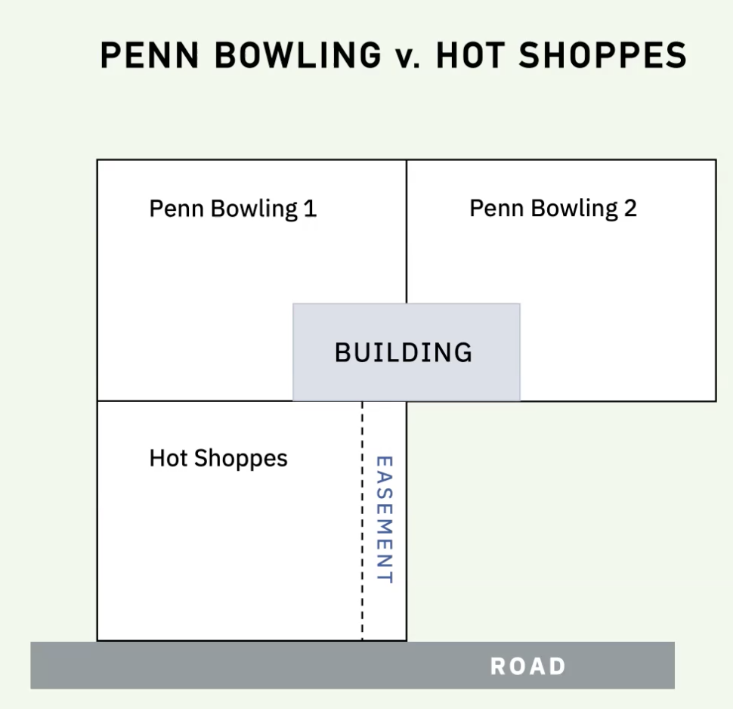

- Covenants
- Agreements that govern what can or cannot be done w/ respect to property
- About the use of land
- Potential subject matter covenant covers is typically broader than easement
  - Because it is saying what you can or cannot do, whereas easements are being more specific about what you can do
  - Covenants are more flexible than easements
- Usually covenants are something to benefit neighbors
  - Eyerman - there was covenant in Kingsburg place prohibiting building certain things → what you can and cannot build
- Both negative (don’t do something) covenants + positive (do something) covenants exist
  - Kramer → racially restrictive covenant
- Purely contractual, unlike easements
  - Are ONLY created via contract
  - MUST BE IN WRITING, SOF APPLIES
- 2 different types of covenants, difference in how they are enforced (remedy sought for breach of them is different)
  - Real covenants + equitable servitudes
    - $ damages → real covenant
    - Injunction → equitable servitude
- Covenants sometimes run with the land
  - Covenants run with the land when they bind successors
How to figure out if covenant runs with the land
- Which party is the burdened party and which party is the benefitted party?
- Which type of covenant is it? → check by looking at remedy sought
  - If unclear, run with it and do analysis of each type
- Is there a burden running, a benefit running, or both?
  - If both, do burden analysis first
  - Is horizontal privity, vertical privity, or both required?
    - Note - no such thing as diagonal privity

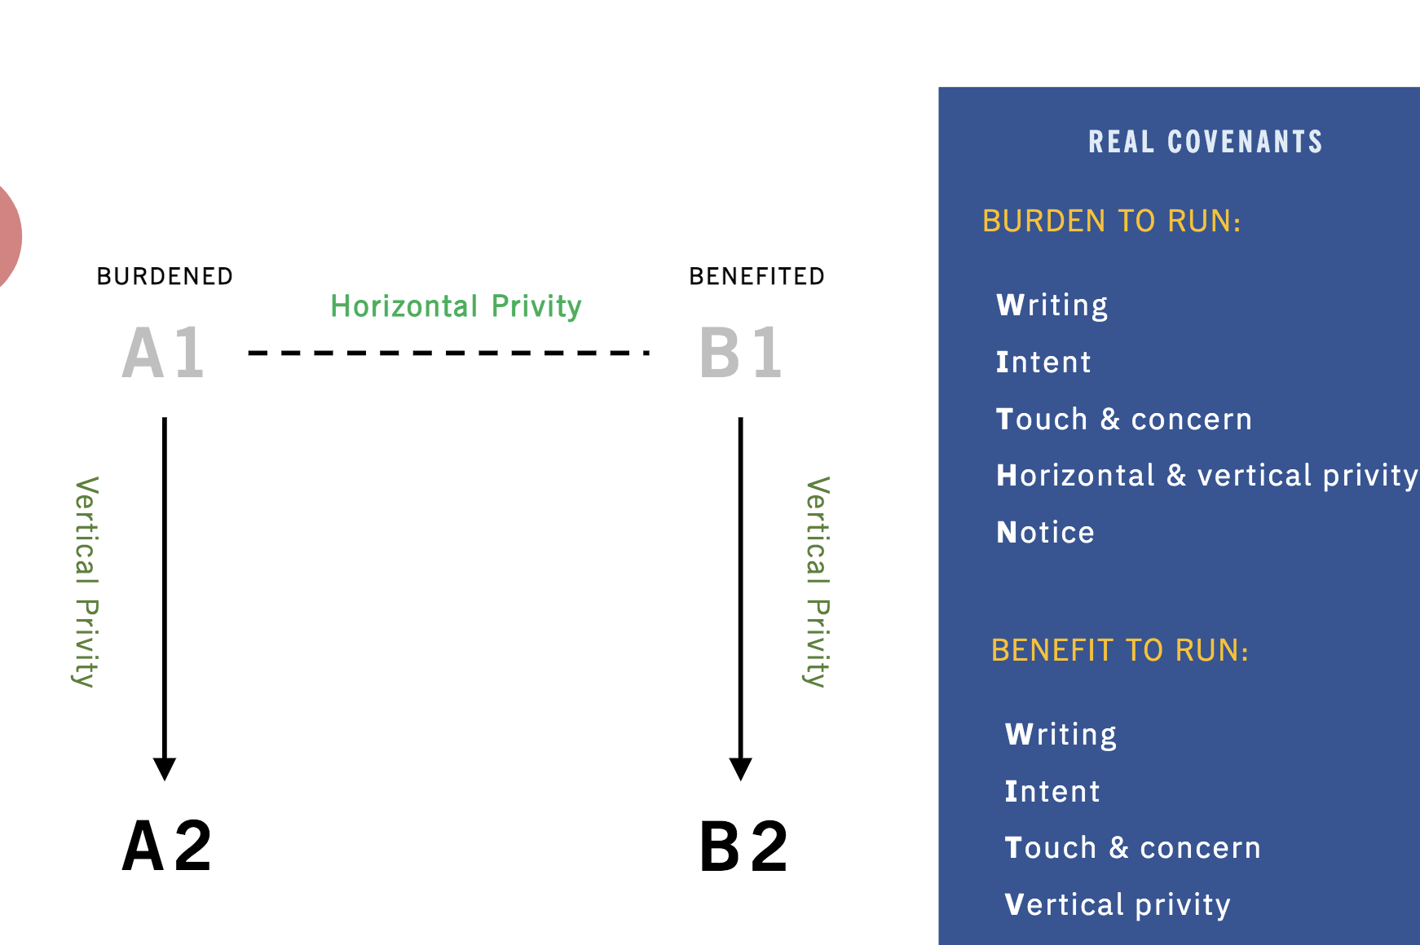

Writing: agreement between A1 + B1 (original parties who created covenant) must be in writing
Intent: A1 + B1 (original parties who created covenant) must have intended for covenant to bind successors
Touch and concern: Neponsit HOA
- Easy to satisfy
- Affects the party’s disadvantages and burdens as owners of a particular parcels, rather than has just party of a community
  - Covenant has to affect benefits and burdens to you as the owner for your specific parcel
    - Burdens + benefits your ownership - not specifically your physical land itself
- Example of what likely doesn’t satisfy → dues for golf course in another country → value of golf course is increased by covenant, but value of lots is likely not affected in anyway
Horizontal Privity
- Must be privity of succession of estate (need not be complete succession)
  - Selling estate (grantor/grantee) OR renting estate (leasee/leasor)
  - Merely being neighbors insufficient for covenant to run with land (can still enter into covenant tho)
Vertical Privity
- Easier to establish cf. horizontal
- Any non-hostile relationship (i.e. any relationship so long as A1 didn’t acquire A2 by AP)
- Complete succession of estate - has to be a grantor/grantee sale
  - A2 leasing from A1 = incomplete succession, renting is no bueno
Notice
- Can be actual or constructive notice*
  - *if in traditional jurisdiction that doesn’t require actual notice for the burden of a real covenant*
  - Record notice → was on the records in county, was on deed, you should have looked
  - Inquiry notice → could have found out if you inquired further
    - Sanborn v. McLean - negative covenant (burden) ran with the land bc D had inquiry notice of covenant; D should have noticed residential building uniformity in D’s subdivision and inquired further to see if there was a negative covenant
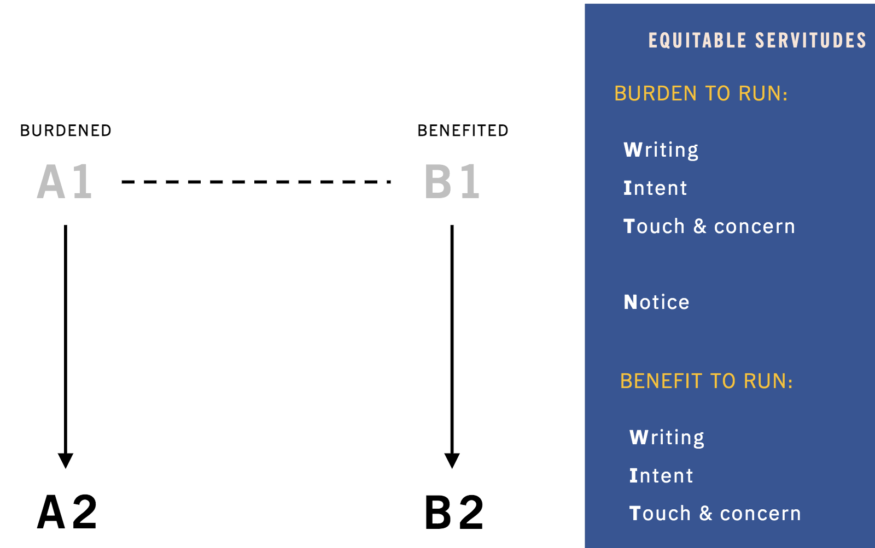

Writing: agreement between A1 + B1 (original parties who created covenant) must be in writing
- In a deed or otherwise
- Note covenant itself doesn’t need to be in writing, just privity
Intent: A1 + B1 (original parties who created covenant) must have intended for covenant to bind successors
Touch and concern: Neponsit HOA
- Easy to satisfy
- Affects the party’s disadvantages and burdens as owners of a particular parcels, rather than has just party of a community
  - Covenant has to affect benefits and burdens to you as the owner for your specific parcel
    - Burdens + benefits your ownership - not specifically your physical land itself
- Example of what likely doesn’t satisfy → dues for golf course in another country → value of golf course is increased by covenant, but value of lots is likely not affected in anyway
Notice
- Can be actual or constructive notice
  - Record notice → was on the records in county, was on deed, you should have looked
  - Inquiry notice → could have found out if you inquired further
    - Sanborn v. McLean - negative covenant (burden) ran with the land bc D had inquiry notice of covenant; D should have noticed residential building uniformity in D’s subdivision and inquired further to see if there was a negative covenant

Below is just the above 2 slides in way more detail

If only B2 is involved and A1 is still original party → benefit running
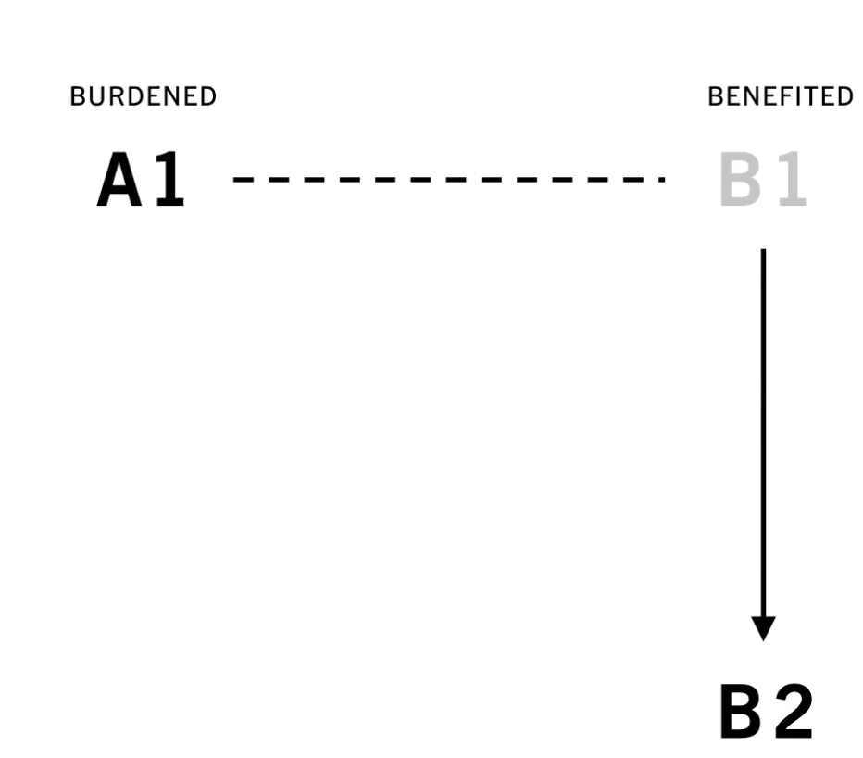
- Agreement has to be in writing between A1 and B1
- A1 and B2 must have intended for benefit to run with successors
- Agreement has to touch and concern the land
  - Must be vertical privity between B1 + B2 (no horizontal privity is required)
    - All that is required is some nonhostile nexus
  - No notice requirement
    - Even if B2 did not have any sort of actual or constructive notice, B2 can still benefit from agreement

If only A2 is involved and B1 is still original party → burden running
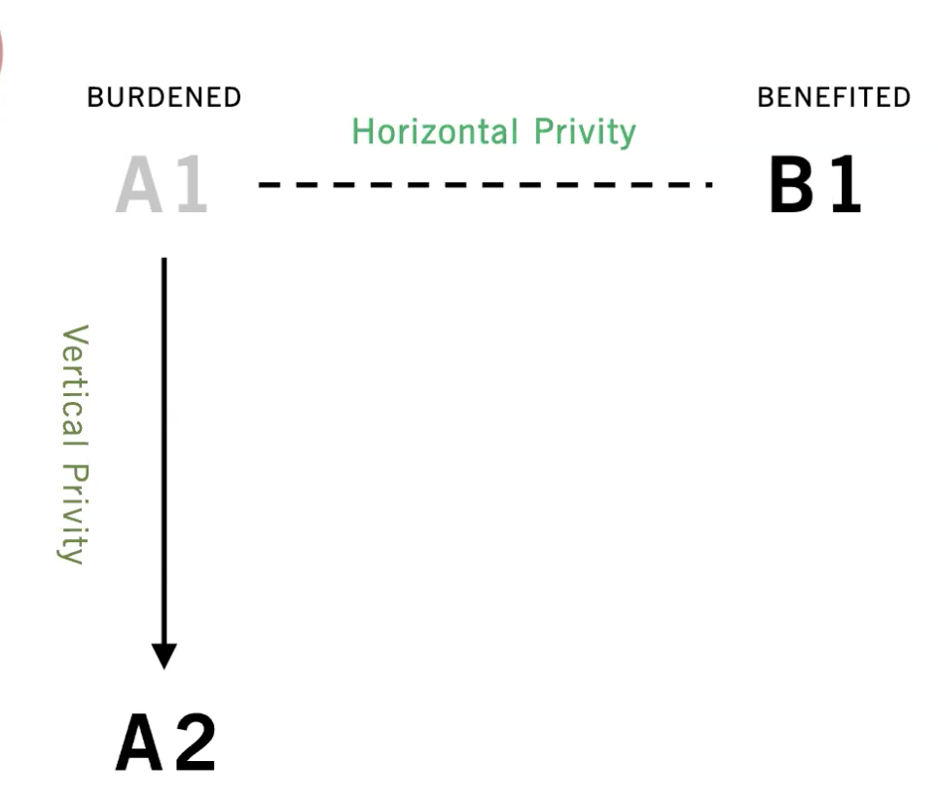

Question: Does the burden of the covenant run from A1 to A2?
For burden of a real covenant to run, the below are required:
- Agreement must be in writing between A1 + B1
- Original parties, A1 and B1, must have intended to bind successors
- Agreement must touch + concern the land
  - Affects parties legal relations as landowners (not just as members of the community as a whole)
- Both horizontal + vertical privity is needed
  - Horizontal privity
    - Relatively difficult to establish
    - Nexus between A1 + B1 must be a succession of estate
      - Selling the estate (grantor + grantee) or taking out a mortgage
      - Common form is developer subdivides property + sells parcels to people
    - A1 + B1 merely being neighbors is not adequate
      - Neighbors can enter into a covenant, but if they want one that runs w/ land, they are out of luck!
  - Vertical privity
    - Easier to satisfy than horizontal
    - #1 Any non-hostile relationship / connection between A1 + A2 will do
      - Basically just means that A2 was not acquired by A1 via AP (if AP → no privity)
      - ANY other way A2 acquired property is good enough
    - #2 There has to be complete succession of the estate, not succession of part of the estate
      - If A2 has just leased from A1 ≠ complete succession of estate
    - #3 Burdened party, A2, must have notice of the covenant before they acquire the property
      - Actual notice or constructive notice
        - 2 types of constructive notice
          - Record notice → its in county registry, if you checked records you would have seen it
          - Inquiry notice → you didn’t know, but you should have asked around, if you did, you would have known
      - Policy reasoning → If A2 knew the parcel was burdened by a covenant, A2 would want to price in the covenant by paying less

If both A2 and B2 are involved → both a burden and a benefit running
  - If you’re in this situation, start with whether the burden runs analysis above, bc its harder for burdens to run then for benefits to run
    - If burden doesn’t run, still do analysis to see if benefit runs on exam
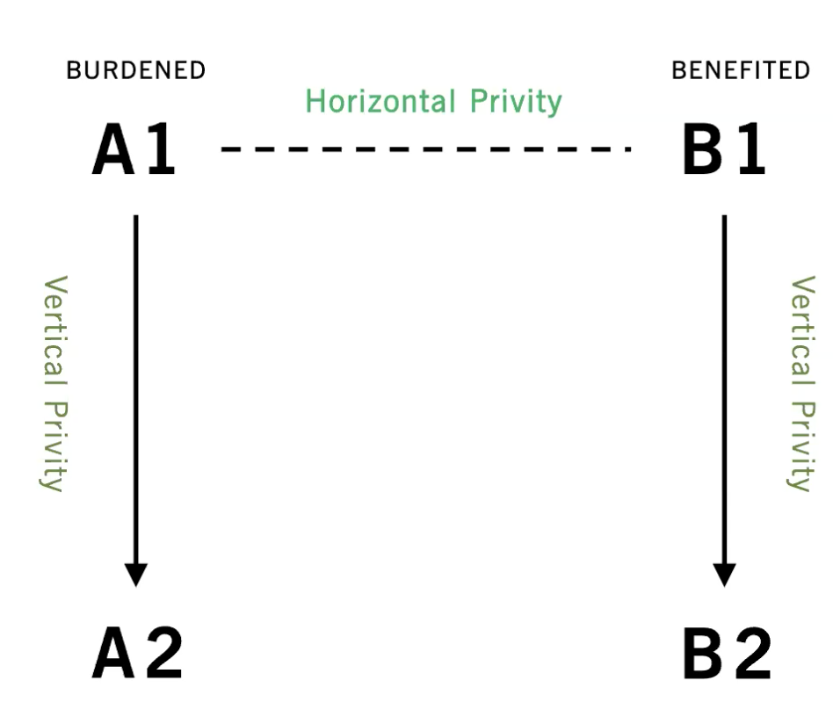

Tulk v. Moxhay 1848 → creates equitable servitudes specifically to get around absence of horizontal privity
- D purchases land w/ provision he would keep private garden a garden, but builds on it anyways
Holding: covenant is enforceable, despite lack of horizontal privity, bc person acquired the property with notice
- Court concerned no one will want to sell land to anyone else out of fear the person will do something w/ the land that makes the land YOU retained less valuable
  - If you can’t prevent someone doing something obnoxious on it, you might not be willing to sell the property → contrary to property law which wants transfer of property bc it encourages efficient use of land
- Unjust enrichment concern as well - cost of complying w/ burden was priced into D’s purchase price
  - If someone doesn’t have to have burden, D got a windfall
→ Lee: reasoning doesn’t make sense bc if burden wasn’t one that could be enforced due to no horizontal privity, WAS it even priced into agreement?
- In creating equitable servitudes, courts basically ditched horizontal privity requirements

Neponsit Home Owner Association v. Emigrant Industrial Saving Banks → covenant to pay HOA fee “touched + concerned” land bc it provided community benefits to owner
Facts: did covenant to pay HOA fee touch and concern the land?
Holding: yes, because covenant affected D’s advantages as an owner of the parcel
- Covenant was done for things that were done in connection with the land but not actually on the land itself
  - HOA dues were for parks / paths / roads near parcel → benefits you get to enjoy by virtue of owning land
- Court endorses Prof. Bigelow’s famous definition of touch + concern
  - Covenant must affect the party’s advantages + burdens as owners of a particular parcel, rather than just as a part of a community
- Does the covenant make owning this parcel less valuable in one way, but also either make owning the parcel more valuable in another way, OR make owning a related parcel more valuable?
- This holding is broader than stuff that just physically affects dity and building of property
- Broadened definition of touch + concern - easy to satisfy

Remember, if neither parties in question are original parties to agreement, you need to check if both the burden AND the benefit run

Sanborn v. McLean - D had inquiry notice bc they should have recognized uniformity of other residential-use lots + inquired to see if covenant existed
Facts: D wants to build gas station on their lot. Lot had covenant that limited lot to residential use, but the covenant wasn’t on all deeds in subdivision erroneously, including D’s.
Holding: Covenant is binding because defendant had constructive inquiry notice of covenant
- Entire subdivision was residential → D should have realized uniformity
- Subdivision plan as residential was repeatedly declared in deeds for subsequent sales of lots → covenant was repeated by others, it was known
- Purchasers of lots that didn’t even have restriction on deed either complied with it
- D is only party to depart from plan in 30 years
- Counterargument→ what if uniformity was accidental? How much inquiry did they need to do? How many deeds had this mistake? How many do you need to check before you’ve done enough?
  - Is this fair to hold purchasers accountable to covenant when they aren’t the one that made a mistake?

How to get rid of covenants
- Negotiate the covenant away
- Abandonment
- Change of circumstances

Bolotin v. Rindge 1964
Facts: P had lot with covenant to limit lots in subdivision to single family residences. P wanted to build commercial building on his lot before covenant expired and argued the circumstances had changed, best use of lot was commercial, lot was unsuitable for single family residences, and commercial build would have no adverse effect on market value or amenities of neighbors (only bring commercial use 100 feet closer than already exists). D argued traffic would negatively impact home value in subdivision.
Requirements for change of circumstances to deem covenant unenforceable
If EITHER of the following are true:

Changed conditions have rendered the restrictions’ purposes obsolete
  - NOT TRUE HERE, people who didn’t want office building did own residential property there
OR

Enforcement would be inequitable, would harass burden party, AND would not benefit adjoining land owners
  - Have to ask is if the neighbors would LOSE any benefit → would they have less pleasant residential neighborhood?
  - Court – important to distinguish between effect on market value (trial courts finding) and comfort and enjoyment of neighbors, which is what matters

Why Is Changed Circumstances Doctrine Useful?
Developer might have made wrong predictions about what future would look like
- D might have thought it should have been residential property, but maybe that was just wrong
- Or, there are many parties to the covenant, so negotiating termination would be impossible, last will try + hold out

Peckham v. Milroy → abandonment of covenant when covenant is habitually + substantially violated
Facts: D ran daycare against covenant banning commercial use in subdivision. D argued covenant was abandoned because other residents had commercial businesses in subdivision.
Holding: Abandonment allowed when covenant habitually and substantially violated
Requirement to for violations of covenant to constitute abandonment of covenant
#1 - Violations have eroded the general plan
#2 - Violations must have been habitual and substantial
- There were violations, but a small amount compared to total lots
#3 - Violations make enforcement inequitable
Criticism of termination by abandonment doctrine
Even if violations are habitual + substantial, is it fair to then say abandonment has occurred and no one is bound by this?
  - If no one was wearing a mask, would we say bc of that, no one should?
  - Shouldn’t poor people who are obeying + getting screwed over by the jerks that aren’t listening be considered?
On the other hand, if we DON’T allow abandonment, are we giving too much power to minority to hold out with society and prevent efficient + beneficial use of land

Nuisance
- Limited by principle sic utere - use what’s yours, do whatever you want, SO LONG as to not harm others others
- But this principle doesn’t prohibit ALL injuries to others
  - Prohibiting all injuries to others would be unenforceable, and some benefits come inherently w/ injuries
    - Ex: rule you can’t inadvertently jostle you on subway
      - You can be protected… but not have the subway
- Other people are compensated by all the advantages of civilized society
  - Want the benefit of the city, you have to deal with the smoke, odors, noise
- Landowners must make reasonable use so as to not occasion any unnecessary damage or annoyance to his neighbor
  - You aren’t prohibited from doing ANY annoyance or harmful use, but you’re limited to reasonable use, that doesn’t cause unnecessary damage or annoyance
What is reasonable depends on circumstances
- Locality rule → use of property in one locality, under some circumstances may be lawful and reasonable, but inappropriate in another neighborhood
  - Is the use appropriate to the neighborhood or not?
  - “nuisance may merely be a right thing in a wrong place”

Rule: To constitute a nuisance, the use must be such as to produce a tangible and appreciable injury to neighboring property, or an injury that renders enjoyment of the property specially uncomfortable or inconvenient

- Specially = diff than is ordinary in neighborhood, related to locality rule
  - Eg on the train, someone punches you
- Injury has to be significant / substantial

Defenses to nuisance
“Coming to the nuisance” defense in some jurisdictions + handled diff juri to juri
- If plaintiff showed up on scene after objectionable activity had already started, he came to the nuisance
- Whichever conflicting use comes later, loses - earlier use has priority
  - If factory comes after house, bad news for factory
- Court here (and many other jurisdictions) rejects this theory → would allow factory to control, essentially, what happens on other people’s property
- ...But same thing is true other way, house is also controlling what the factory can do
  - Aren’t both people causing a nuisance, in some way?
  - Controversial defense
  - Another issue is this can encourage wasteful races to be “first” to use it in your obnoxious way
  - → because of the above, courts are reluctant to recognize this defense
  - When unclear who showed up first, court balances factors like who got there first, good faith, spite, public interest/benefit to public, promissory estoppel/detrimental reliance, etc.
Estoppel/acquiescence
- Should have said something before you invested, now you can’t complain
  - Don’t apply here because P invested before he knew D was burning bricks, so D’s use wasn’t priced into P’s purchase
Prescriptive easement
- PEs can allow someone to commit a nuisance
  - Here, D did not have a PE - one requirement of PE is continuity and here, there was not 20 yrs of continuous use (some years he didn’t burn bricks)
Remedies for nuisance
- Injunctive relief applies to:
  - Avoid interminable litigation or multiplicity of suits
    - e.g. gas everywhere would have been recurring, want to avoid other people bringing same claim
  - Or avoid irreparable injury (injury not remedied by $ damages)
- If either situation above applies, you still must balance the hardships/equities
  - Injunctions can still be denied on the basis of balance of hardships
  - If the injunction would be excessively burdensome on the defendant, in light of a relatively small benefit to the plaintiff, might not get injunction
  - Must look at potential harm to society if injunction is not granted
    - Look at harm to society if D were to get an injunction/P were not to get an injunction
Anticipated nuisances do not have a COA because there isn’t actual interference yet

Campbell v. Seaman 1876
Facts: P buys property + builds house on it when D is not burning bricks in adjacent property; D resumes burning bricks, which causes toxic gas to ruin P’s extensive landscaping
Holding: D is liable for nuisance bc gas goes from D onto P’s property frequently enough “that some injury is to be expected.”
- P has right to enjoy his land + landscaping, injunction is an appropriate remedy to preserve P’s interests moving forward (P can replant trees!)
- D didn’t have any defenses; P cannot be estopped bc P didn’t buy or build knowing D would burn bricks, and no PE bc no continuous use

Trespass & Difference w/ Nuisance

Adams v. Cleveland Cliffs Iron Co. → dust + vibrations that interfere with owner’s use + enjoyment of land = nuisance, not trespass bc no significant, physical intrusion
- How to determine if a particular conflict is a trespass or a nuisance
- D operated iron mine and expanded mine 3x (1 time of which may have been after P had moved there)
- P lived in nearby town + sued for BOTH trespass + nuisance
  - Argued mine generated dust, noise, vibrations which resulted in P clean the house all the time, replace cracks, windows, plumbing breaks and leaks, psychological harms in form of nervousness and sleeplessness, and diminished home value, so much that they couldn’t sell it
- No trespass bc noise + vibrations are not tangible, and dust is not a significant enough physical intrusion
Requirements for trespass
- Invasion of your property that is both
  - Done by physical, tangible object
  - Invasion is direct (ct claims to liberalize formality of directness rule)
    - No intervening force caused thing to go onto property (like wind)
    - “Occurs by some means that D had knowledge to substantial certainty, or should have known, was going to cause a physical invasion”
- Recall per Jacque v. Stenberg Homes, you get nominal damages for trespass, even w/o any damage at all

Requirements for nuisance (one approach, not same one as Campbell or Jacque, its a different approach)
- Have to pass balancing test based on social value of the activity
  - How beneficial is activity?
  - How harmful is activity?
  - Do we care about these benefits + harms?
  - Is society better off with harm + benefit, and no harm but no benefit?
- To get damages, you have to prove there’s actual + substantial injury

4 standard tests to tell diff between nuisance and trespass
some jurisdictions use, one, combination of some, all of them
- Was defendants act on plaintiff's land or was defendant’s act elsewhere?
  - Trespass v. nuisance
- Was harm of D’s activity direct or indirect?
  - Trespass v. nuisance
- Was invasion by tangible matter or intangible?
  - Trespass v. nuisance
  - Are invading items individually visible to naked eye?
- Did P lose possession, or merely enjoyment of property?
  - Trespass v. nuisance

Calabresi & Melamed: “Cathedral Paper”
- Court must decide not only which side to favor, but whom to entitle, which entitlements are protected, whether an individual is allowed to sell or trade the entitlement, the kind of protection to grant
- Three types of entitlements:
  - Property
    - An entitlement is protected by a property rule to the extent that someone who wishes to remove the entitlement from its holder must buy it from him in a voluntary transaction in which the value is agreed upon by the seller
    - Least amount of state intervention
- Liability
  - Whenever someone may destroy the initial entitlement if he is willing to pay an objectively determined value for it
  - The value may be what it is thought the original holder of the entitlement would have sold it for
  - Additional stage of state intervention – not only are entitlements protected, but their transfer or destruction is allowed on the basis of a value determined by some organ of the state rather than the parties themselves
- Inalienable
  - Transfer is not permitted between a willing buyer and a willing seller
  - The state not only determined who is entitled and to determine compensation is the entitlement is taken away or destroyed, but also to forbid its sale under certain or all circumstances
  - Limits or regulates the grant of the entitlement itself
  - Most entitlements to most goods are mixed
- How is price determined?
  - By the person who holds the entitlement (property)
    - Better when transaction costs are low
  - Someone else (liability) – court sets price to defendant to compensate plaintiff
    - May be better when transaction costs are high
- Most scholarship that follows Calabresi have assumed that property rule protection means mandatory relief (an injunction or no liability) and liability rule means payment of monetary compensation, but the textbook authors see this as an oversimplification.
- Property rule – cannot be taken without holder’s consent
- Liability rule – can be taken by what amounts to a forced sale
- Common starting point in literature discussing this is that courts have a choice regarding if property or liability and the assignment of the entitlement to the plaintiff or defendant
  - Property Rule: the price of the entitlement is determined by the parties and the entitlement is given voluntarily → injunction
    - P gets the entitlement – Campbell v. Seaman
    - D gets the entitlement – Hinman v. Pacific Air
  - Liability Rule: the price of the entitlement is determined and given by someone else (usually a court) money damages (usually according to fair market value)
    - P gets the entitlement and liability rule protection, however is required to accept money damages in exchange for dealing with nuisance - Boomer v. Atlantic Cement
    - D gets the entitlement – Spur v. Webb
- When there are many plaintiffs as part of one party – Boomer v. Atlantic Cement
  - Too costly to negotiate with each P (assembly problem)
  - Each P has an inventive to hold out and ask the other party for money (hold out problem)
→ the most economical solution is to (1) hold for P and (2) protect entitlement with liability rule (solves both the assembly problem and hold out problem)
- Inalienable Entitlement: transfer isn’t allowed at all
Three factors as to assigning initial entitlement:
- Economic efficiency
- Distributional preferences
- Other justice considerations
  - If transaction costs are high, there may be circumstances in which shifting to liability is preferred on efficiency grounds
- Another argument here is that courts may have more limited information than the parties about the benefits and costs of allocating entitlements

Calabresi: Cathedral
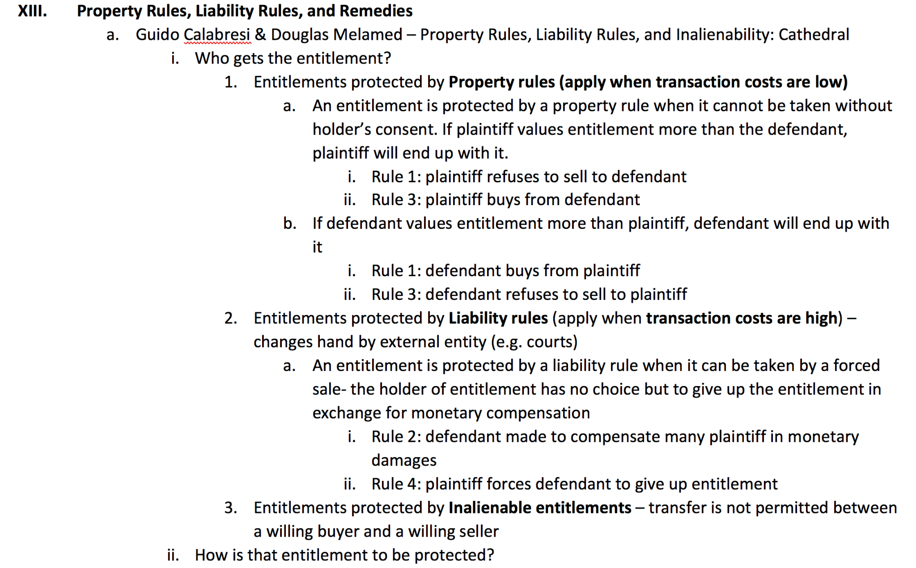

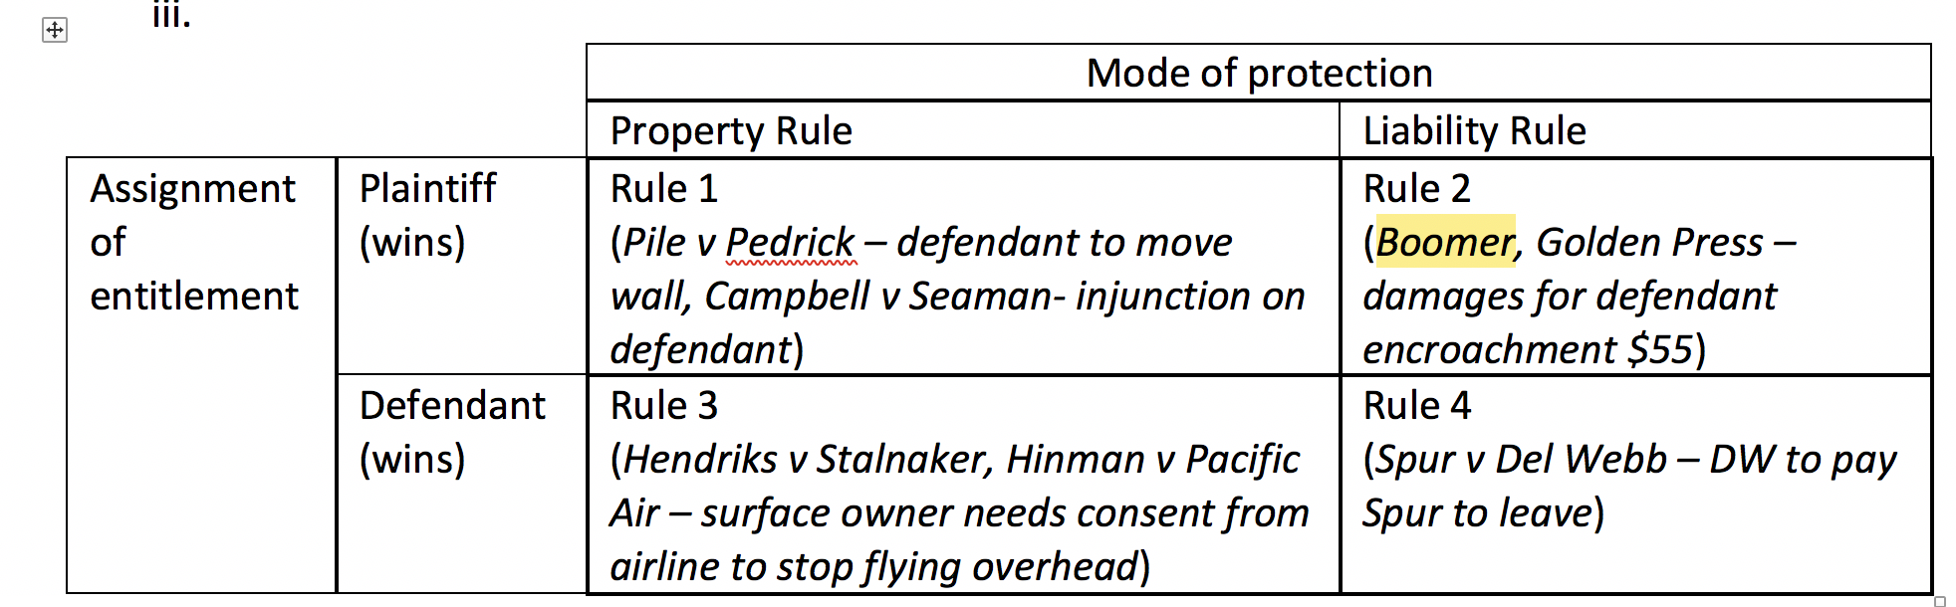

Property Rule – entitlement is protected by a property rule when it cannot be taken without the holder’s consent; protection against trespassers
Liability Rule ($ damages) – entitlement is protected by liability rule when it can be taken by what amounts to a forced sale
To protect the entitlement with a property rule or a liability rule, must address three factors:
- Economic efficiency
- Distributional preferences
- Other justice considerations
Boomer v. Atlantic Cement Co. → liability rule w/ P entitlement - cement plant dust
Facts: D’s cement plant spews dust, smoke, and vibration. P sues for nuisance and wins. Injunction was denied but temporary damages allowed.
Issue: Could single recovery be had, w/o court issuing permanent injunction?
Three options
1) Issue an injunction
2) Issue an injunction but delay injunction until technology/industry advances to not cause nuisance to residents
3) payment of damages to plaintiff (Rule 2)
- Court applies balancing test, balancing effects of granting / denying injunction
  - Here, significant harm to plant for shutting down, esp. In comparison to P’s harm, which is relatively small in comparison
  - Injunction would be costly
    - D would have to get permission from all Ps → hold-out problem & assembly problem
Holding: P get liability rule protection (has entitlement bc nuisance)
- P is required to accept $ damages in exchange for dealing with the nuisance → special type of injunction, where you can pay $ damages to not obey injunction
- Result gives factory an easement to continue polluting
  - By paying damages, factory now has entitlement to commit the nuisance, a the cost of the damages
- Court should focus on 2 parties before it rather than considering policy implications → not courts job to do that
Dissent: pollution is bad, we should stop it

Zoning
- Similar to covenants, but typically broader scale and done by the government
  - Zoning is done by law (ordinances)
Two ways to potentially avoid zoning regulations
- Seek a special exception → written within ordinance itself
- Request for variance
  - Variance = exception due to hardship, given on case by case basis

Village of Euclid v. Ambler Realty Co. → zoning ordinance is constitutional bc its justified for public welfare
Facts: Village had 6 difference use zones; each zone was assigned certain activities and organized together (“good” zones, single family homes, parks + less favorable zones, cemeteries) → use zoning
- Cumulative zoning: area zoned for particular use, permissible to engage in that use, in addition to any use that is less intensive (i.e., more pleasant)
  - You can build duplex in U2-U6, aka anywhere that allows more intensive use
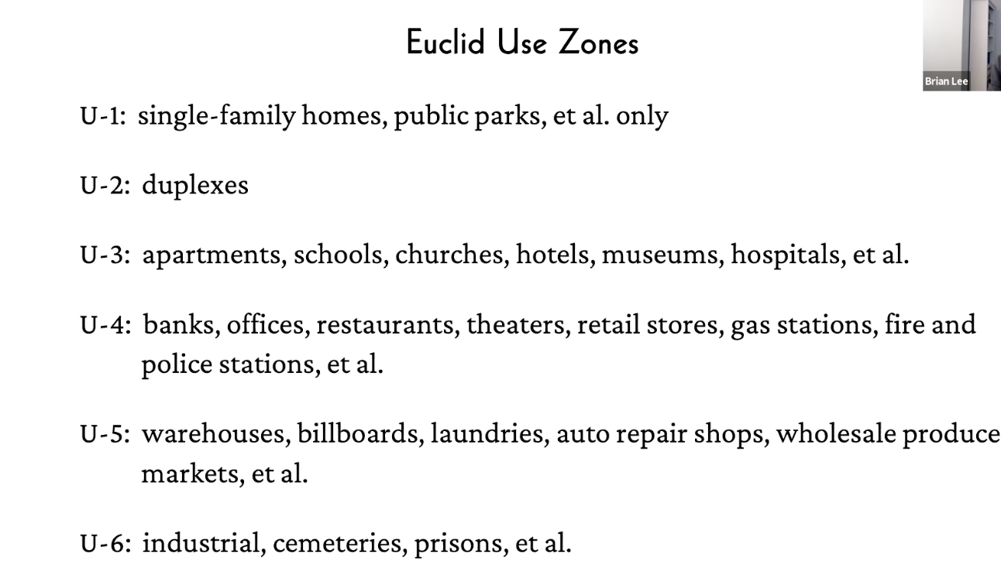
- P’s land had different portions of the use zones on it + result was P could not build commercially + thus value of land was significantly decreased bc no one would want to buy it
  - P argued ordinance violated P’s DP rights
Holding: A legislative zoning classification will survive constitutional scrutiny as long as the classification is “fairly debatable.”
- Will be constitutional unless it is “clearly arbitrary + unreasonable, having no substantial relation of public health, safety, morals, general welfare, etc.”
  - Here, D found justification of ordinance in some aspect of D’s police power → public welfare
    - Excluding industry, apartments in single-family home are makes sense, preserve neighborhood, don’t want “parasitic” apartments + shops in residential neighborhood

Terminology
- Non-conforming uses: uses that pre-existed prior to zoning, but do not conform after zoning, are grandfathered in + allowed to remain
  - Even if lot existed prior to zoning, you cannot build something on it after zoning and call it a non-conforming use → building itself had to exist + be in use prior to zoning
  - Also cannot swap uses if you are a non-confirming use
    - Can’t swap over to being a school, for ex
- Amortization: some, not all, jurisdictions, use amortization to phase out non-conforming use after a specified period of time
  - You can keep doing what you’re doing, but, you have to stop doing it + comply with zoning ordinance in X # number of years

Exclusionary Zoning
- Earliest zoning targeted characteristics of users rather than uses
  - Enforced economic + residential segregation
- This is now unconstitutional

Southern Burlington County NAACP v Township of Mount Laurel – low and moderate income families excluded from municipality

- Note doctrinally, this case is complete outlier
Facts: City protected tax base by forcing developers who had 3 school age children in a multi-family home to pay public school fees → result is low + middle income people can’t live in the area
Holding: Zoning as an action under the police power must promote the general welfare and cannot be motivated by other considerations such as minimizing the local property tax rate
- City has presumptive obligation to not make housing impossible for low + middle income people
- Lee: Is this best addressed using zoning law, and not taxing employers + giving vouchers to low-income people to housing?

Ellickson hates zoning
- All you need is nuisance law + private covenants
- Yes, you need court to keep eye on covenants, but this will work

Criticisms of zoning
- Rent seeking → if gov is giving benefits, this incentives people to lobby to the government
  - Note rent here is “economic rent”, political power, not actual rent
  - Those that have power political power + influence are more likely to benefit from zoning
- Regulatory/legislative capture → gov regulatory entities can be “captured”, influenced, by the very organizations they regulate

Private ordering is also problematic
- People are going to scheme for the best economic benefit they can get, esp the evil rich people in power

Dividing Ownership Across People & Time

Overview of Present & Future Interests
Estate: property rights defined in terms of their duration through time
- Temporal measure of a property right

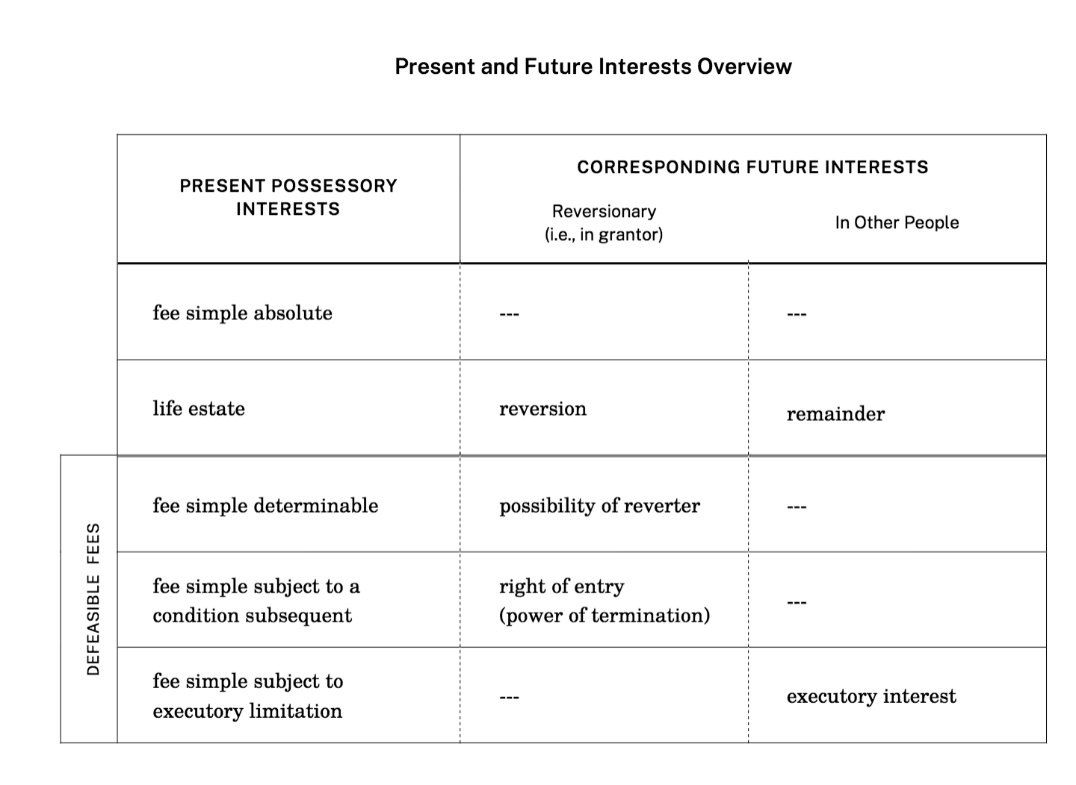
Present Possessory Interests

Fee Simple Absolute
- Largest package of property rights you can have - everything else is less
- If transferring property + don’t specify otherwise, it is presumed you are transferring a fee simple absolute
- Indefinite, runs to infinity
- Granted by language such as “I grant Black Acre to Jones.”
  - As long as you are alive, you may have heirs apparent (not just “heirs” until you’re dead)
    - Heirs “apparent” bc you might change mind about who’s your heir
      - Eg. “to Jones and his heirs” just means to Jones bc Jones is alive + thus has no heirs
  - Fees simple absolute → plural version
Life Estate
- Interest that gives you a right to possess the property, but right terminates automatically upon death of named person
  - Estate exists as long as certain person is alive
  - Can be transferred → alienable by gift or by sale
    - Life estate pur autre vie → life estate that’s measured by the life of somebody OTHER than the person who holds it
      - Estate will be measured by original holder’s life
Complete succession of estate for vertical privity in covenants
- If A1 owns Black Acre in fee simple Absolute, and transfers life estate to A2, that is NOT complete succession of estate, bc life estate doesn’t last as long as the fee simple absolute (which is… FOREVA!)
  - It’s only partial succession of estate

Defeasible fees
- Allow ownership to change if some specified event occurs
  - But whether event will actually occur or not is uncertain → might happen, might not
  - If it does happen, estate is terminated / if it doesn’t happen, estate is not terminated
- This is in contrast to a life estate, which inevitably always ends, they will always terminate
- Defeasible fees → might not terminate, you don’t know
- Many states statutes require defeasible fees be limited in their duration, that it be 30 yrs or so, after that, they’re just locked in

Three types of defeasible fees
- These enable people to make 2 choices: who gets the possession interest, original grantor or someone else? Does this transfer occur automatically, or can the recipient decide whether to accept the thing?
  - If an event happens, who gets it, and does the transfer happen automatically or at discretion of the other party? → answer to these Qs determines which sort of defeasible fee you want to create

#1 Fee simple determinable
- Ends automatically if a named event occurs
- Created using durational language - language of time
  - As long as, while, until
- If conditional event occurs, interest automatically goes back to original grantor

#2 Fee simple subject to a condition subsequent
- Continues indefinitely until a named event occurs
- But if named event occurs, IT DOES NOT AUTOMATICALLY END
- Original grantor can choose to end it via self-help or law
- Created by conditional language
  - But if , On condition if, If
  - Set off by commas
- Eg. “To Meghan Markle, but if you ever become part of a foreign royal family, then the grantor has a right to re Enter and retake the property”

#3 Fee simple subject to executory limitation
- If triggering event occurs, the possessor right DOES NOT go back to the original grantor; instead it goes to some third party
- Durational or conditional language
- Eg. “To Chelsea, but if she ever appears on a reality TV show, then to Ivanka.”
  - Difference between condition subsequent + executory limitation is that it’s going to a third party
- Appears to works automatically → not a thing where 3rd party has a choice to take it or not
- No 3rd party discretionary analog (aka they can’t refuse it, have to take it)

Corresponding Future Interests
Reversionary (I.e., in grantor)
- Interests in the original grantor, the person who created this whole thing in the first place

- NEVER situation where NO ONE has possessory interest → someone can always take
  - Even if there’s a grant that doesn’t explicitly who can take at any given time and looks like a gap, there’s someone implicitly that can take

- No revisionary for fee simple absolute (lasts until end of time)

- Life estate → Reversion
  - If grant to A for life, when A dies, life estate goes back to original grantor
    - OG then has a reversion

- Fee simple determinable – possibility of reverter
  - Follows every single fee simple determinable, and only single fee simple determinable
  - Nothing that isn't a fee simple determinable has a possibility of reverter
    - Unique: fee simple determinable & possibility of reverter
  - Returns possession to the grantor w/ possibility of reverter
    - FSD in offeree and possibility of reverter, implicity, in offeror
  - Possibility of reverter is automatic - it happens if triggering event occurs
    - Implicit if fee simple determinable doesn’t say what happens exactly if event occurs
      - “I will do X as long as there’s a train station on 14th St.”
      - Durational language creates fee simple determinable
- AP clock can start to run if the holder of fee simple determinable, who should vacate once triggering event occurs, but doesn’t

- Fee simple subject to a condition subsequent → right of entry (power of termination)
  - Goes back to original grantor → right of entry, or power of termination
    - Gives OG the right, but not the obligation to retake
      - Note latches may bar exercising this right if OG waits too long!
      - If you’re going to exercise your right of entry, then you need to do so within a reasonable time after getting the right
    - OG can choose to let former possessor stay there

- Fee simple subject to executory limitation → no reversionary interest bc whole point of this is that the right goes to the other person

In Other People
- Fee simple absolute → none bc lasts for lifetime
- Life estate → future interest, if there is one, is a remainder
  - Eg. grant to A for life, then to B → B is not OG, doesn’t have reversion, but has a remainder
  - Remainders can be any form of these present possessory interests
    - Eg. since no qualification on B’s remainder interest, it’s just a remainder in fee simple absolute
    - Eg. if to A for life, then to B for life → B has remainder in life estate to B
- Fee simple determinable → no right in other people, if triggering event occurs, goes back to OG
- Fee simple subject to a condition subsequent → no right in other people, if triggering event occurs, goes back to OG
- Fee simple subject to executory limitation → executory interest
  - Future interest correspondent goes to other people if the triggering event occurs

Examples/hypos

“To A for life, then to B and his heirs”
- creates a life estate in A and B has a remainder in fee simple absolute (or fee simple, same thing)

If C comes in adversely, and APs the land, C will assume possession until the end of A’s life
- C has a life estate por otra vez → lasts for as long as A’s life - NOT C’s life
  - Remember - whatever the person can AP is what the other party has and nothing more bc of nemo dat, so C can only have/adversely possess what A has
B still has a remainder in fee simple absolute
  - After A dies, B would have the remainder
At this point, A has nothing because B has the remainder
A’s life estate was adversely possessed by C, but once A dies, C is trespassing on B - NOT adversely possessing
  - If C meets the requirements for AP (remember, clock restarts again) then yes, he will AP it again - but C CANNOT restart the clock until B actually has the present possessory interest, bc otherwise there’s nothing for C to AP

- O grants Blackacre to Huxley College as long as it's used for instructional purposes
  - Huxley College has a fee simple determinable bc this is a contingency with durational language
    - “As long as”
    - Cf. a fee simple subject to a condition subsequent that uses conditional language → “but if,” “on condition that”, “provided that”, “provided however”, and “if”
- O grants Blackacre to A, but if marijuana is inhaled on the premises, then O shall have a right to re-enter and take the promises
  - A has a fee simple subject to a condition subsequent bc it uses conditional language and also, O has a right to re-enter and take the premises
  - O has a reversionary interest → a right of entry (or power of termination)

- O conveys Blackacre to A for life, then to B for life, then to C.
  - A has a life estate
  - B has a remainder in life estate
  - C has a remainder in fee simple absolute

- O grants Blackacre to A for life, then to B for life, then to B’s children who survive B.
  - A has a life estate
  - B has a remainder in life estate
    - Recall, a life estate can’t be followed by a life estate, it has to be a remainder in life estate, otherwise B would be able to on the property when A is still living + possesses it
  - B’s children have a remainder in fee simple absolute
  - O has an implied reversion in life estate
    - Suppose B has 2 children and they both die before B does → then, B has remainder in life estate → when B dies, the property would have gone to B’s children, but they are dead
  - Someone always has to be able to take - it can’t go to no one
  - Therefore, there is an implicit reversion back to O
  - Remember, if the future interest is in the grantor, then it is a reversion - if it's to someone else, it's a remainder
    - Because of this possibility, there is an implicit reversion back to O
    - This reversion goes away if one of B’s children survives B
    - If O is not alive at that point - it goes to O’s estate

How to keep property in the family
- Note if grandfather gave the properties to his children as fee simple instead of as a life estate with a remainder in each life tenants issue (grandkids), then the children could have sold it to anybody, instead of definitely giving it to their own children (grandkids)
- Life estates with remainders in their kids ensures for at least 1 generation, the property stays in the family
- Grandkids can sell bc they have remainder in fee simple absolute

Waste
- The ability to divide property rights across time gives rise to the possibility of conflicts across time
- Person who holds a remainder = remainderman
- Holder of life estate might take action that the remainderman, the people who might come to possess the property later, might not like

Problem of divergence of interests
  - Eg. chopping down trees that take a long time to grow!
- Law tries to mitigate the divergence of interests with the doctrine of waste
  - This is the default rule, basic rule law applies unless relevant rights holders agree to do something else
    - E.g. if the right holders all agreed to remove the trees

Types of Waste

Affirmative waste
  - Person w/ present possessory interest is doing something bad
    - Not normal use, rather, use that causes excess damage
    - Use that causes normal wear and tear is NOT affirmative waste
        - Eg. Chopping down ornamental trees; this isn’t just normal wear and tear, this is not normal, bad
Permissive waste
  - Person w/ present possessory interest DOESN’T act
  - Unreasonable failure to act which causes excess damage
    - Eg. roof starts leaking but person doesn’t fix roof - they didn’t do anything when they should have acted to prevent excess damage in the form of water damage

Ameliorative waste
  - Significant change in the property
  - Although its a change, unlike the other 2 changes in affirmative in permissive waste, this change increases the value of the property, changes the property in a way that makes the property “better”
    - Typically “better” = increases market valuable
  - Today, this waste can be allowed, if there are changed circumstances
    - You can do ameliorative waste sometimes, not always

Brokaw v. Fairchild 1929 → ameliorative waste, even though it makes property value better, can still be form of waste / life tenant has right to use estate, but NOT right to act like owner / knocking building down is acting like owner
Facts: P, a remainderman, had inherited a mansion from his father and wanted to knock the mansion down and build apartments, claiming he couldn’t rent the mansion for enough to cover the tax bill. The other remaindermen who also inherited mansions located nearby objected and argue knocking the mansion down is waste.
Holding: If you have a life estate, you do not own the property, cannot act like an owner, and must pass the property to remainderman in similar condition. Thus, P cannot knock the mansion down because to do so is wasteful.
  - Demolishing property = act of ownership
  - The property must pass to the remainderman “as nearly as practicable, unimpaired in its nature, character, or improvements,” otherwise, it’s waste
- If you have a life estate, you can just use the estate, but you can’t impair what it is that is handed down on to the remainderman
- Doesn’t matter if the remaindermen would or would not be financially better off
  - Not all values can be reduced to monetary values
    - Even if everyone would be better off financially, doesn’t mean they’d be better off all things considered
    - They may have lost irreparable sentimental value
- Same idea as in Bolotin v. Rindge - just looking at market value of property is not enough, must consider other aspects of property outside of market value that are important to people

Restraints on alienation
- Transferability of property can be socially beneficial
  - Allows allocation of resources to the highest valuing users
  - Promotes owner autonomy, allows people to decide who gets property next
- Absolute restraints on alienation are void as against public policy
  - Exception → courts typically will uphold limited restraints on alienation, so long as restraints are reasonably related to some family estate planning objective
    - For eg., not allowing a minor to alienate property until minor has reached adult age
  - Exception → there are absolute restraints of alienation the law itself imposes
    - Eg. Inalienable entitlements by law → body parts + bodies

Odd Fellows v. Toscano → restrictions on use of land are okay, restriction on users of land are void as a limitation on alienation
Facts: D granted lot to P as a gift to operate lodge on, provided lot would revert back to D if either the lodge sold, any part of the lot was transferred, or if P stopped using the lot for lodge purposes.
Holding: The limitation on the grant that the interest would revert back to the grantor if the lodge was sold or if the lodge transferred the lot is an invalid absolute restraint on alienation
- Provision that D gets it back if P stops using it for lodge purposes, however, is valid restraint on alienation
  - Restriction is valid bc it is a restriction on use, even though has the effect of restricting eligible users only to the lodge itself
    - Restriction on use = ok
    - Restriction on user = not ok
- Restriction on use is a valid fee simple subject to a condition subsequent
Dissent: If effect of the two restrictions is identical, they should be treated as identical and thus both provisions should be invalid as absolute restraints on alienation.

- Generally, in cases in which language is ambiguous as to whether it creates a fee simple determinable or a fee simple subject to condition subsequent, courts tend to favor the fee simple subject to condition subsequent because it will avoid automatic forfeiture

Potential issue with any defeasible fee that doesn’t have a time limit on it → fragmented ownership could result and all fragmented owners will have to agree to a deal
- Reversionary interests might pop up in the future
- For eg., lodge uses lot for something other than lodge → lot reverts back to OG → if OGs are dead, to OGs kids, but if kids are dead, grandchildren might be dead → great grandkids each own a small bit of the property and have to agree to a deal amongst each other
- Several jurisdictions place time limits on defeasible fees, like 30 yrs

Concurrent Ownership Interests
Possible to have multiple owners at the same time - “co-tenancies”/concurrent interests
- Could grant to A for life, then to B and C
  - A gets a life estate
  - B and C together have a remainder in fee simple
- Also possible for A to own property in fee simple, while B simultaneously has a life estate in the property
  - During B’s lifetime, there are shared property rights but once B dies, it’s all A’s

Popular alternatives to these types of co-tenancies
- Trusts, corporations, business partnerships → multiple ppl having property interest in a single thing

Four basic types of concurrent interests

- Tenancy in Common
- Each tenant is an owner
- Each tenant in common has an undivided interest in the property
  - Each has the right to possess the whole
    - Eg if Jack + Jill own a house as tenants in common, Jack cannot exclude Jill from the living room, Jack cannot exclude Jill from the kitchen, etc.
  - ...But, these interests are separate
    - Each interest is thus independently alienable
      - Jack can sell his interest w/o getting Jill’s permission - each interest is separate and thus each owner can transfer it to whoever he wishes
  - Share sizes do NOT need to be equal
    - Co-tenants may have unequal rights to profits or to rents from the property
    - Co-tenants may have unequal responsibilities/obligations
  - Co-tenants do not have any property rights against each other
  - No co-tenant can demand rent from another co-tenant

- Joint Tenancy
- Similar as tenancy in common w/ 3 major differences
  - #1 Joint tenancy has a right of survivorship
    - When one joint tenant dies, his interest vanishes, and any other joint tenant’s interest increases proportionately
      - Survivors have a right to the deceased tenants share
      - Rationale → if one interest vanishes, you don’t want gap in interest, someone has to always have an interest
  - This is true REGARDLESS of wills
    - Another hypo - if Blackacre is owned by 3 tenants, A, B, C who all have equal shares, and A dies, B and C would each own a half of Blackacre - this is true regardless of what A’s will said
  - Implication → don’t want to enter into joint tenancy unless you trust the joint tenants

  - #2 Joint tenancy requires satisfying the “four unities”
    - Unity of possession - each joint tenant must have an EQUAL right to possess the whole (same as tenancy in common)
    - Unity of time - each joint tenants interest must have been established at the same time
    - Unity of title - each tenant got their title (ownership share) via the same instrument
      - AP can be the same instrument (its possible, doesn’t just need to be via deed)
    - Unity of interest - they must all have a fee simple, or a life estate, or a lease
      - The interest has to be the same type for all joint tenants
    - Some states have relaxed time + title requirement bc it's easy to get around via a straw transaction anyways

  - #3 Joint tenants share sizes must be the same
    - Each tenant must have the same size shares
      - In minority of states, you don’t need to have shares same size
      - Note if exam says something is a “properly formed joint tenancy” , you assume that it is and move on. Don’t try and challenge the asusmptions/facts given in fact pattern

Below 2 are for marital property only

- Tenancy by the Entirety
- Exists in a number of states, but not all
- Holdover from the fact that under the common law, for many centuries, married women were not allowed to own property in their own name
- Similar to joint tenancy - has a right of survivorship, requires satisfying the four unities to create
  - Fifth unity - have to be married to have it
- Marriage is a unit, property belongs to the unit → key difference is neither spouse can unilaterally transfer property that’s held by the tenancy by the entirety or by incumbent (can’t take mortgage out against it)
  - They can transfer property ONLY IF the other spouse agrees
  - Both spouse must agree to any transfer the interest or incumbent
- Can’t get out of a tenancy by the entirely unilaterally
  - Have to get other spouse to agree OR get divorced → only way to get out of tenancy by the entirety

- Community Property
- Alternative to tenancy by the entirety → state has one or the other, but not both
- All property acquired in a marriage automatically becomes community property, regardless of which spouse acquired it
  - Equal right to possess community property
  - Alienation or encumbrance of community property requires consent of both spouses
- If spouses divorce, community property is divided equally 50/50, unless spouse can show it was separate property (which means it's not governed by community property)

Both tenancy by the entirety + community property require permission from other spouse to transfer property, but difference is that in community property after divorce, all property is divided equally

Hypo
Grant gives blackacre to A and B.
- Assuming they’re not married they are either a tenancy in common or joint tenancy
  - Without further specification, it is presumed it is a tenancy in common
  - Presumption is that it is a tenancy in common

Resolving Disputes Amongst Co-Owners

- Future Interest Disputes → doctrine of waste will step in to place restrictions on what present owner can do (or in permissive waste, should be doing) to protect co-owners long term property interests
- Concurrent Owner Disputes → court generally won’t intervene; waste is generally disfavored as remedy for concurrent owner disputes
  - Remedy is partition
    - If you don’t like relationship, you can get out of it
- Co-tenants in tenancy in common OR joint tenancy have an automatic right of partition → they can just leave and get out of it

How is co-ownership otherwise regulated outside of remedy of partition?
- A co-owner can make threat of exit → I’ll leave unless you do X
- Or, have a contract between parties that sets out norms that govern proper use

Delfino v. Vealencis → partition by sale / partition in kind
Facts: Two families owned a plot of land as tenants in common. The Delfinos owned 69% and Vealencis owned 31%. Vealencis lived on the land + operated trash removal business out of property as well. Delfinos did not actually have possession of their parcel (they lived elsewhere). Delfinos wanted the court to order partition by sale, but Vealencis wanted partition in kind.
  - By sale - sold at auction + divide $ proportionate that matches ownership shares
  - In kind - physically dividing property up between parties + each party will own their part all by themselves
- Vealencis want partition by kind bc she wants to remain on the property and continue operating her business
- Delfinos want to build residential subdivision on their property post-partition; betting they will win at auction to buy Vealencis part of the plot
Rule: Policy is to favor partition in kind, unless both of following are true:
Have to have both conditions!
  - Dividing in kind would be impractical or inequitable
  - Selling the property would be better to serve owner’s interests

Application: Physical partition is feasible - subdivision is possible even with the business present
- Owners interest - Delfinos might lose market value by having the business next door, so yes, physical partition is not in THEIR interest, but you have to consider BOTH parties interests
  - Vealencis home + livelihood depended on being on this property for several yrs
- Only one set of owners interests would be served by physical partition, so the second requirement isn’t satisfied
  - The second requirement is that ALL owners interests would be better satisfied by partition by sale
- Court orders partition by kind
  - Trial court had divided up the property in kind - gave Vealencis only 1 acre out of 20.5 acres, and ordered her to pay an owelty
  - Owelty = payment to correct an imbalance that arises from partitioning in kind
  - Partitioning property in kind often cannot be done in exactly the way the parties interests are apportioned
    - Unique physical characteristics of property - like a ridge unevenly dividing the property
      - Person who gets smaller portion pays $ to the other party (an owelty) to ensure the market value of what everyone gets is 50/50

- Today, most states still favor partition in mind in some shape or form
- Might be a trend for support for partition by sale, which makes sense bc modern property is less likely to be easily divisible
  - Against partition by sale → sentimental value to property that cannot be valued in dollars, social cost going to be lost in the sale bc no one is going to pay more for the property just bc it has an extra sentimental value for you

Partition is not the only relief co-tenants can seek
- Under some circumstances, co-tenants can receive a damages award against the other co-tenant

Gillmor v. Gillmor → ousted co-tenant can sue co-tenant for damages for refusal to accommodate co-tenants demands
Facts: Co-tenants shared land used for cattle grazing. Defendant who had possession kept plaintiff, who had a right to use the land for her cattle to graze, from doing so. This goes against co-tenancy in common, because each tenant has an equal right to possess the whole.
If co-tenant is ousted from possession, ousted co-tenant can sue for their share of rents and profits from the common property, aka “accounting and damages.”

#1 → Awarding an Accounting and Damages
- Only applies if there’s been an ouster
Ouster = if party in possession excludes the other party or acts in a way that necessarily excludes the other party
  - Mere fact other property used the property isn’t enough, even if the other party is the only party to use the property → bc every co-tenant has a right to use and occupy the property, as long as the use doesn’t interfere w/ other parties equal right
- Here, there was ouster bc there needed to be accommodation between the two to accommodate both of them grazing, but D was unwilling + grazed so much that P could not graze w/o overgrazing and ruining property

- Court awards accounting in damages because there was a clear, unequivocable demand to the tenant in possession combined w/ a refusal to accommodate the co-tenants demand
  - Court awards an accounting in damages

#2 Contribution - contributions can be required among co-tenants, but not always
- Ordinarily if a co-tenant who possesses a property unilaterally makes improvements to the property, the co-tenant who does so cannot demand the other co-tenant help pay for them → can’t pass cost on to other tenant
  - Tenant who made changes is responsible for entire cost of changes
  - This is general rule - there are exceptions
    - #1 If co-tenant in possession did so in good faith belief they were the only one who owned the property → in this case, court may require contribution bc otherwise its unfair

    - #2 estoppel scenario
      - Co-tenant who’s out of possession but knew the co-tenant in possession was making the changes, but kept quiet about it, even tho they didn’t approve of the improvements
      - Estoppel might step in and require B to contribute

    - #3 if repairs were NECESSARY in order to preserve or protect the property, both parties should share in the cost of that

- Here, D was seeking contribution for fence he put up
  - Court says he can get contribution if he proves the repairs were necessary AND expenses were reasonable
- Court says here there should be a contribution, this is cattle grazing property, you need a fence around it, that's a necessary expense

Severance
- Converts a joint tenancy to a tenancy in common
  - NOT partition - partition converts joint tenancy or tenancy in common into SEPARATE ownership, fees altogether
- Severance does NOT eliminate the co-ownership relationship
  - It converts joint tenancy to a tenancy in common
    - Either joint tenant can unilaterally sever a joint tenancy, in common law, you do this by severing one of the four units by for example engaging in straw transaction
Harms v. Sprague
Facts: Two brothers owned property in joint tenancy. John created a mortgage interest in Simmons and left his share of the property in his will to Sprague. John dies.
- If the mortgage to Simmons severed the joint tenancy, John and William would own simply as “tenants in common”, and tenants in common do NOT have a right of survivorship → thus when John died, his will WOULD be effective and Sprague would get the interest
#1 Does a mortgage by one joint tenant sever the joint tenancy, creating a tenancy in common?
- No. Destroying one of the 4 unities would - if John had SOLD his interest to Simmons, that would have severed the joint tenancy. But a mortgage does not involve a transfer in this way. There hasn’t been a conveyance, so that doesn’t severe the joint tenancy
  - Note it could have, if John stopped making the mortgage payments and redemption period expired, Simmons would be able to take the property
- Unilateral mortgage does not sever the joint tenancy

#2 Does the mortgage survive the mortgager’s death as a lien?
- Does John’s real property interest that was securing the mortgage still secure the mortgage after John dies?
- No. This was a lien on the giver, John’s, interest. Once John dies, his interest vanishes, it is not transferred. When John died, his interest vanished and his interest was the interest that was securing the mortgage. Once John’s interest is gone when he dies, there’s nothing left securing the mortgage, so Simmons loses out as well.
  - Simmons no longer has the security for the mortgage, but Simmons might still be able to make a claim that he is owed the $, might not be able to get it bc he lacks the security interest, but in practice can raise a claim
- Thus, Williams retains 100% of the property

Simmons should have required both joint tenants sign the mortgage, so he could have recovered.

What if Williams died first?
- John now owns 100% of the property. The mortgage is now, as a general rule, still secured only by John’s original interest in the property, not the new, 100% interest

Unilateral mortgages doesn’t sever joint tenancy
- Courts differ as to if a unilateral lease severs a joint tenancy - depends on jurisdiction
- Courts do agree one tenant murdering another tenant does sever the joint tenancy
- If John had sold his interest to SImmons, that would have severed the joint tenancy

Leases
- Leases transfer possession, so transfer the right to exclude, unlike licenses or easements, which are rights to use, not to possess

4 types of common law leases

Term of years
- Lease that ends automatically on a definite, fixed ending date (could be less than 1 year)
  - If more than 1 year, has to be in writing
  - Bc it ends automatically, neither party needs to give notice

Periodic tenancy
  - Automatically rolls over/renews for a specified period of time
  - Periodic tendency also ends on a certain date, but automatically continues to renew until another party stops it
    - Like a month to month lease
    - Either party may terminate, but termination typically requires advance notice, with the time period usually being the same as the lease period
      - If it’s a year to year, generally don’t have to give 1 yr notice - depends on jurisdiction
Tenancy at will
  - Can be terminated by either party at any time for any reason
  - Many jurisdictions do require advance notice
    - How much notice usually depends on the payment period
      - If you pay monthly = 1 month advance notice

Tenancy at sufferance
  - Not really a lease/tenancy at all bc tenant doesn’t have any real right to possess at all
  - Arises when there’s a lease, lease ends, and tenant doesn’t leave
  - Tenant is different from a trespasser bc a trespasser didn’t have permission to ever go on the property
    - Tenant at sufferance did have permission, at some point…
  - Landlord has right to evict, but may not have a right to self-help

Big theme in leases is allocation of risk
- Law sorting out how to allocate risk in situations where there are asymmetries of information and control between landlord + tenants

Paradine v. Jane → tenant bears the risk that a third party might dispossess tenant of property
Facts: P sued D under a lease for years of unpaid rent. D argued D was forced out of possession of the property due to invasion of an enemy during war.
Holding: The covenant of quiet enjoyment is separate from the covenant of a tenant to pay rent.
Covenant of Quiet Enjoyment doctrine: landlord themself will not interfere with tenants possession/enjoyment of the land → but is NOT a guarantee no one else will interfere
- Tenant takes all of the risk tenant might benefit from land - and all of the risk they might be burdened, too
  - Tenant doesn’t need to share the profits of the land, but likewise, cannot burden landlord with lack of profits
- When party by his own contract creates a duty upon himself, he is bound to the duty notwithstanding accident, because he could have provided against it in the contract
→ Rent is duty created by the parties, and D must make it good, regardless of interruption from enemies, for the law will not protect him beyond the agreement
- D must run the burden of casual losses and cannot place burden on P lessor

Since this case, law has moved away from independent covenants and towards linking of covenants.
- Important exception of even independent covenants → If house is totally destroyed, you don’t have to pay rent
- Commercial leases → more like common law, which is more similar to the holding of this case (the covenants are independent) and NOT similar of residential leases today

Smith v. McEnany → covenant of quiet enjoyment and covenant to pay rent are dependent covenants
Facts: P, landlord, intentionally encroached on tenant, D’s, leased property with a wall he built by only about 9 inches to 2 feet. D withheld rent and P sued.
Holding: A landlord deliberately and intentionally depriving tenants of possessing even just a small amount of property justifies tenants ceasing to pay rent throughout the duration of the encroachment.
- Even a small deprivation violates covenant of quiet enjoyment
- Covenant to pay is conditional on covenant of quiet enjoyment being fulfilled
  - However, a covenant for the tenant to maintain a shed on property was considered an independent covenant to landlord's covenant of quiet enjoyment, thus tenant was obligated to still maintain shed
- Significant departure from Paradine v. Jane, where tenant was displaced but still owed rent, whereas here, tenant isn’t even displace and still doesn’t owe rent
- “Land is hired as one whole. If, by his own fault, landlord withdraws a part of it, he cannot recover.”

Medico Dental v. Horton & Converse → remedies for breach of covenant
Facts: P owned a medical building and leased a space out to D, a drugstore. The lease had a restrictive covenant that prevented P from leasing any other portion of the building to another business selling drugs. D found out another tenant, a doctor, was selling drugs to his own patients. D rescinds its lease and stops paying rent. P sues D for the unpaid rent.
Holding: The restrictive covenant and covenant to pay rent are dependent. Thus, tenant is allowed to withhold rent while lessor is violating restrictive covenant.

Evidence covenants were dependent / intended to be linked → look at intent of the parties
- Both covenants were in a rider together
- Plain language of agreement
- Obvious the subject matter of the covenant to not have competition in the building was crucial to D and thus likely a material part of consideration that induced D to enter agreement / agree to pay rent
- Court also considers fact breach was substantial → maybe court would hold covenants were independent had breach not been substantial

Options for Remedies
- Rescind the lease (what D did)
- Stay with lease, but sue for lost profits for violation of the covenant
- Rescind the lease later, and sue for damages between time of breach + when they rescinded

In general, major breaches tend to be treated as breaches of dependent covenants.

Sutton v. Temple → caveat lessee - let the tenant beware, no implied warranty of fitness
Fact: D leased P’s patch of grass to field his cattle in. D and P did not know the grass had been poisoned with paint. As a result, D vacated the land prior to his lease termination date and refused to pay for the rest of the lease. P sued for the remaining lease.
Holding: Tenant has to pay lease because of caveat lessee - let the tenant beware.
- There are no implied warranties of fitness in leases; the tenant bears the risk that the property will turn out to be unsuitable for the tenants purposes, unless the landlord committed fraud in concealing the problem, or the two parties negotiated explicitly to create an express warranty of fitness.
  - Note, even though there is no implied warranty of fitness, it’s always possible there could be an express warranty of fitness - but rare for parties to agree to that in a lease
- Landlord didn’t misrepresent grass so absent fraud, the tenant has to pay the remaining balance.
Reasoning: Tenant is allocated the risk bc tenant has better knowledge of knowing what tenant wants and if the property is suitable for tenants purposes

Mitigating caveat lessee

Blackett v. Olanoff → constructive eviction
Facts: Landlord rented one parcel of land as a residency and an adjacent parcel to a club. The tenant of the residence claimed the club was too loud, so left and argued constructive eviction.

Constructive conviction = someone’s conduct substantially interfered w/ tenants use and enjoyment of the leased property AND the landlord can be held responsible for that conduct

- Here, the music was very loud, no question it substantially interfered with tenants use + enjoyment, and the landlord can be held responsible for the club’s conduct because they knew when renting the space to operate a club, noise would be a natural and probable consequence, and landlord also had ability to tell club to not be as noisey
  - Landlord could control the club (they had told club to quiet down before + they had for short period of time, shows they had control over tenant)
Holding: The club music being too loud to live in a residential apartment constituted a constructive eviction and thus the tenant can get out of their lease.
- For tenant to claim constructive eviction, tenant needs to have vacated property in reasonable time

Gotlieb v. Taco Bell Corporation → surrender of property when landlord sent lease proposal to new potential tenant
Facts: P agreed to lease property to TB for 20 years. TB agreed to get government approval to open the restaurant, but were permitted to cancel the lease if they couldn’t get approval within a 6 permitting period beginning when the lease started. Community groups opposed TB.
TB both filed for a permit and repudiated on the lease on the day before the end of the permitting period. P sued TB for breach of lease and for unpaid rent. D refused to pay. Over a year into the lease with TB, P leased the property to Rite Aid at a higher price than TB’s lease was.
Holding: Landlord accepted TB’s surrender by operation of law / implied acceptance; landlord meeting with Rite Aid was more than a mere attempt to find another lease, it demonstrated intent to accept TB’s surrender.

Landlords have 3 options when tenants attempt to repudiate/surrender a lease before its expiration:
- 1) Reject the repudiation and do nothing → tenant still liable for rent

- 2) Accept repudiation, re-enter and relet the property to someone else for the landlord’s benefit
  - Original lease no longer exists, tenant no longer owes any rent, and landlord just has lease w/ new tenant. Attractive option for landlord if market rate has gone up / landlord can find tenants for higher lease

- 3) Reject the repudiation, enter the premises and relet for the tenant’s benefit
  - Acting as the agent of the tenant
  - Tenant remains liable for any difference in the rent between the original contract amount and what the landlord is able to get for leasing it to someone else
  - Attractive option for landlord even if market rate hasn’t gone up / if market rate has stayed the same / maybe even if market rate is lower bc landlord doesn't need to worry about recovering tenants rent, landlord can find better tenant who will pay rent

Surrender can be accepted 2 different ways
- An express agreement or by operation of law
  - Explicitly or implicitly
  - Was there an express agreement between the parties that repudiation is accepted?
OR
  - Was there an implicit acceptance of the repudiation / acceptance of repudiation by the operation of law?
    - Some act so inconsistent with landlord/tenant relationship, which implies their intent to deem lease terminated, acceptance of repudiation would be implied → eg. changing the locks
  - Applies even if there was an “outward refusal” to accept the repudiation
    - If landlord declares they rejected the repudiation, but changes the locks, the landlord has implicitly accepted the repudiation

Once surrender is accepted, the tenant is off the hook. They owe nothing for rent due after surrender.
- Here, P was not merely meeting with Rite Aid to try and find another lessee; when P sent a lease proposal to Rite Aid, they implied acceptance of TB’s surrender.

Duty to Mitigate

Sommer v. Kridel → landlord must take reasonable efforts to relet property after original tenant repudiates
Facts: D puts down deposit and signs 2 year lease, but breaks lease a month before lease started. Landlord eventually relets apartment to someone else at the same price, but 16 months after the apartment had first been advertised. Landlord sues D for 16 months of rent plus the security deposit (who knows why 16 PLUS security deposit, that’s false math).
Holding: Duty to mitigate requires landlord take reasonable efforts to lease property to someone else after lessee breaches, and the landlord bears burden of proving they took reasonable efforts.

Duty to mitigate is majority rule in US for residential property
  - Commercial leases → generally no duty to mitigate

Tenant can plead both surrender and duty to mitigate in the alternative
- Even if tenant didn’t successfully surrender lease and is thus bound by it → landlord still might have duty to mitigate, which could in turn limit tenant’s damages
- Which one applies, surrender or duty to mitigate, makes a financial difference to the tenant

If landlord doesn’t accept tenant’s surrender → landlord relets on tenant’s behalf
- Tenant is obligated to pay landlord’s reasonable costs of reletting
- Tenant has to pay its full rent until landlord finds new tenant
  - If new tenant’s lease is less than original tenant’s lease, tenant will have to pay difference in rent for each month remaining on original lease

If landlord does accept tenant’s surrender → landlord relets on landlord’s behalf
- Tenant has no obligation to pay any rent once landlord accepts surrender
  - After surrender is accepted → lease disappears
  - Even if landlord is reletting at a loss, tenant still doesn’t have to pay
- Attractive option if market rate has risen → landlord can get higher rent, tenant doesn’t need to be on the hook bc landlord doesn’t need tenant’s rent anymore bc landlord is getting it from someone else, everyone is happy

If duty to mitigate applies…
- Landlord has duty to take reasonable efforts to try and relet apartment
  - Court decides what is reasonable amount of time to relet apartment
- Tenant still liable for full rent during reasonable amount of time to relet apartment

- If landlord relets apartment during reasonable amount of time
  - Tenant is liable for full rent during reasonable amount of time + difference between relet rent and tenant’s original rent if there is a difference → if surplus, landlord gets to keep
- If landlord hasn’t relet apartment after reasonable time has passed
  - Tenant is liable for the difference between what the landlord could relet the apartment for and their rent
    - If market rate is same as tenant’s rent → tenant liable for $0
    - If market rate is more than tenant’s rent → tenant is also liable for $0, but landlord should be incentivized to accept tenant’s surrender + get a higher lease

  - This is a big difference if market rent is less than tenant’s rent, and small or no difference if market rate is close to or equal to tenant’s rent

  - If landlord is not reletting because the market price has dropped
    - Landlord might still save more $ NOT fulfilling duty to mitigate
      - If fulfilled duty → landlord would lose $ by having to rent at a lower price, and tenant isn’t going to be liable once landlord relets apartment after reasonable time has passed
      - If didn’t fulfill duty → landlord gets the difference between tenant’s rent and market rent, which is significant and close to tenant’s rent
        - Better for landlord to not fulfill duty + keep getting (almost all of) tenant’s rent v. low market rent

Reletting on the tenants behalf = not accepting surrender, tenant still needs to be in picture
If landlord is reletting on behalf of the tenant, this means that the landlord has not accepted the surrender of vacancy
- If lease is done on behalf of the tenant, surrender has been rejected
- If landlord accepts the surrender, landlord is reletting on HIS own behalf
- If landlord does NOT accept surrender, landlord is letting on TENANTS behalf

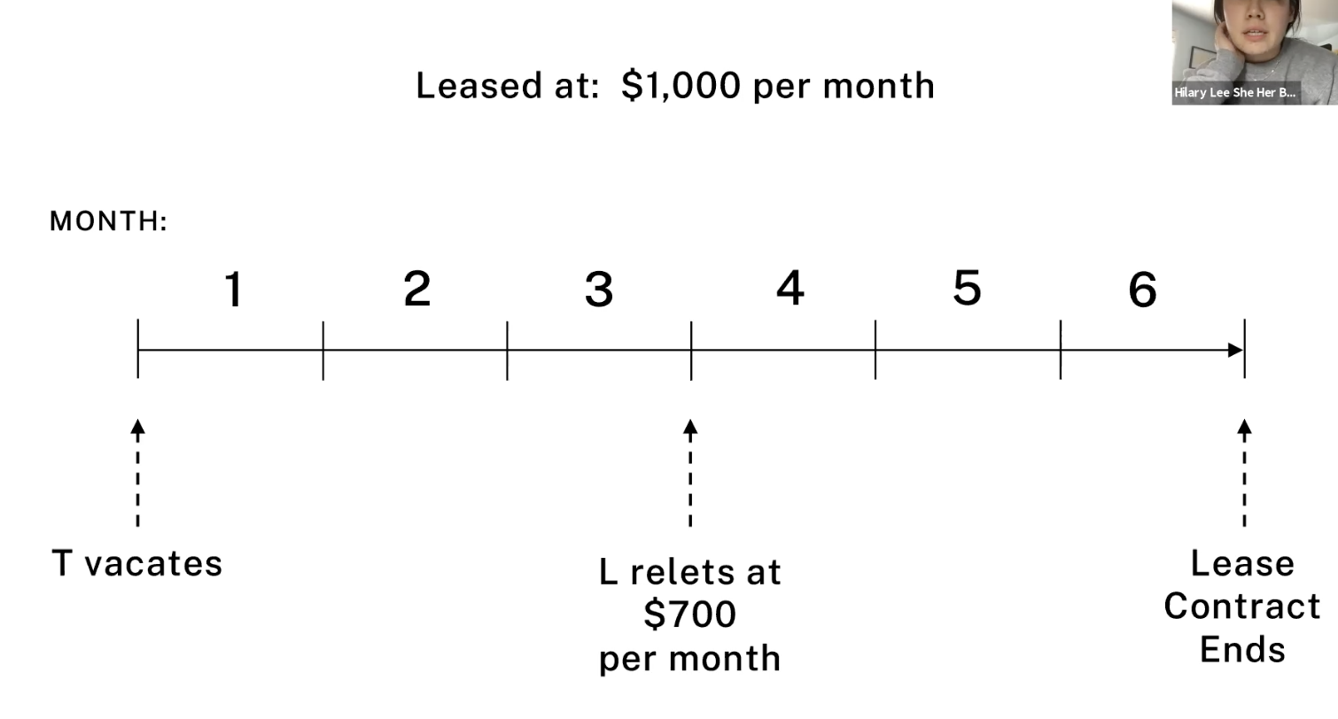

Javins v. First National Realty 1970 → implied warranty of habitability
Facts: Tenants withheld rent due to various violations of housing code in their apartment.
Holding: There is an implied warranty of habitability as defined by the Housing Code and it is dependent on the tenant’s implied covenant to pay rent.
- Moving away from old rule where tenant bears burden for all repairs, even major repairs
- In most jurisdictions, this warranty is statute, and it is not waivable - it is a mandatory rule
- Implied warranty of habitability is dependent on tenant’s implied covenant to pay rent → if landlord breaches, tenant doesn’t have to pay rent
  - Potential exception → If there is only a partial breach, tenant might be exempt from paying only part of the rent (get a discount)

Rationale for making implied warranty of habitability
- 1) Common law default rule (old rule) no longer makes sense in the modern world
  - Tenants are no longer handy, good at repairing things, incompetent urban dwellers, modern housing more complex so harder to repair
  - Tenant cannot internalize the full benefit for repairs that are made
  - Tenants frequently move since they are renting, so if they repair the property they get no benefit
    - Landlord can internalize all the costs AND the benefits for repair
      - Landlord can charge more money after tenant moves out

- 2) Landlord tenant law should be consistent with consumer protection law
  - Law implies warranty of fitness for consumer goods, makes sense we imply it for housing too

- 3) Unequal bargaining power
  - Standardized form leases lead to unequal bargaining power
    - (Real concern if there’s only one set of terms available, monopoly situation, all landlords are using the same form)
    - Empathized the standardized being the issue → not the form itself
    - No meaningful consumer choice for standardized monopoly
  - Race and class discrimination
    - More limits on places you can rent → more leverage sellers/landlords have as supply gets constrained

- 4) Poor quality housing hurts the entire city
  - … but why is it that this should fall entirely on landlords and not the entire city?
  - Why are public housing, vouchers not the solution? Why is the city (gov) not responsible for this? Who should be paying for this - the government/city or landlords?

In sum, leases for urban dwelling units should be “treated like any other contract”
- Treat leases like ordinary contracts → similar to Sommer v. Kridel rational
- Lee critiques the rationale that leases are really being treated like contracts
  - Unwaivable warranties are not typical in ordinary contract law…

Takings Law

Eminent Domain

Power of eminent domain is often said to be an implied attribute of sovereignty.
- Gov must have this power merely by virtue of being a gov
  - To be a gov, gov has to have eminent domain power
- Eminent domain in US is both federal and state gov
- Power is typically delegated to smaller entities
  - Lower tier entities, commonly towns or cities
  - Sometimes might even be delegated to some businesses
    - Typically utility companies + railroads
  - Sometimes even delegated to individuals who have landlocked property (easements by necessity)
  - Sometimes individuals will use eminent domain to obtain easements of access across another person’s property to avoid being landlocked

Eminent domain power is limited by both statutes and the constitution.
- 5th Amendment + 14th Amendment Due Process Clause, people get to be heard + challenge gov authority to exercise imminent domain
  - Fifth Amendment Takings Clause
    - “Nor shall private property be taken for public use without just compensation” → federal provision, but has been incorporated to the states
    - Most state constitutions also have similar clauses → but note they can be interpreted differently than the federal constitutional cause, even if they are written exactly the same
- Eminent domain proceeds are referred to as condemnation proceedings
  - Person who owns property being taken = condemnee
- Voluntary exchanges are often possible
  - Gov can purchase property instead of exercising eminent domain

Economic Justification for Eminent Domain
- Property markets are often “thin markets” → real property is not “fungible”, the unique aspects of real property are valued by owners, 10 acres in one place is not the same as 10 acres in another place
  - Recall common law doctrine → every property is unique
- Owner of real property has a “local monopoly”
  - Often not possible to substitute some the property w/ some other property
  - Eg. you need to get property in that specific location, but you can’t, bc owner has “local monopoly”
- Creates potential of strategic holdout problems
    - If project requires acquiring large amount of property w/o eminent domain, significant potential a land owner will hold out selling property to project owners
- Similar to concern re: issuing injunctions in ways that give one party too much bargaining power over another party → owner of local monopoly has significant bargaining leverage
  - Result is either project owner has to pay insane amount of property, has to build project around property, or may not be able to do project altogether → potential of economic waste
- Also possibility that people are just emotionally holding out → have value to the specific property

Calabrese & Melamed
- Property rule protection means that if the entitlement changes hands, it will do so only at a price agreed to by the property owner
- If outcome of this is socially costly, then you can give the gov the entitlement and the property rule protection, which allows gov to confiscate the land to build railroad, etc, so that we all get the social benefit of the railroad

- The law does the OTHER Calabrese Melamed category
  - Gives entitlement to OWNER, but protects it only with liability rule protection
    - This means entitlement can change hands at a price that is set by an external entity (in eminent domain, the market value of property) rather than what property owner would demand
      - Addresses holdout issues

Basic structure of takings law is in Fifth Amendment
- “Nor shall private property be taken for public use without just compensation”
  - Two requirements of imminent domain power
  - Must be for public use and just compensation must be paid
    - Public use requirement
      - Later 20th century, meaning was broadened from just things open to public to include more things to qualify
      - Having some public purpose, public benefit
        - SC gives great deference to state legislatures in determining the definition of this
    - Just compensation requirement
    - US v. Miller, USSC → property’s fair market value
      - Defined as what a willing buyer would pay a willing seller in cash
      - Does NOT include sentimental value, bc hard to quantify

- Taking land to expand coast guard academy → yes
- Taking land from one private person to give to another private person → no
- Taking land from private owner to give to another private entity as part of a public economic development project? → is this public use or not?

Kelo v. City of New London, Connecticut USSC 2005
Facts: D approved new development project that involved using eminent domain authority to seize private property to sell to private developers for a public economic development project. City argued the purpose of project was to create new jobs and increase tax revenues from the sale of property. Ps brought suit arguing project violated public use requirement of Fifth Amendment.
Holding: Yes, city may validly exercise eminent domain authority to take private property to distribute to private developers; this fulfills the public use requirement required of the Fifth Amendment.
Reasoning
- No pretext and city carefully formulated the plan
- No principled way to distinguish economic development from other public purposes → sometimes better serving the public must be done through private enterprise
  - However, merely generating tax revenue might not be a good enough reason
  - Federalism argument → great deference to states to determine public needs
    - States are free to establish more constitutional protections if you wish
- Court rejects use by the public test - taking does not need to be specifically for use for the public, rather, can be taken for public benefit, as long as there is a genuine purpose to the public benefit
  - Pretext isn’t allowed, but as long as its non-pretextual, that’s good enough
Policy reasons
- Use by the public test is difficult to administer
  - How much access to the public is enough?
    - For eg., schools are only accessible by children, but has a public benefit to everyone
    - For eg., can’t just go on air force base

- Use by the public test is pretty constrained
  - Limits number of things that are going to qualify under this, and limiting it this way is impractical

Doctrinal reasons
- Hawaii Housing Authority v. Midkiff → state transferred ownership of residential property from the owners to the lessees
  - SC upheld→ public purpose was “emining the social and economic evils of land oligopoly”
- Burman v. Parker → state took over blighted area and redeveloped it for various purposes, including roads, schools but also leasing or selling the properties to private parties for redevelopment, specifically for affordable housing
  - SC upheld

Dissent, O’Connor: Beneficiaries of this sort of thing are those that have political power; people who have political power will be immune to takings whereas those w/ no political power will be harmed
- Transferring private property to another private entity is inherently problematic
- Slippery slope → so long as something more socially valuable exists, everything is prone to be taken
- Cf. Hawaii + Burman, both achieved DIRECT benefits, here thre is no affirmative harm that is being addressed
  - Indirect vs. direct benefit
Dissent, Marshall: there is racial bias in the application of these takings
Implications
- Many states have amended their state constitutions to prohibit the sorts of takings Kelo allowed

Today’s principle justification is an economic one, based on the problem of intractable holdouts
- Someone people will just refuse to relinquish their property
Eminent domain came up based on the problem above, but there are constraints per prior notes
Kilo - expansive understanding of what satisfies public use requirement
Having some public purpose is enough → even if its taking property for economic redevelopment by private organizations

Regulatory Takings
- If gov is acting under police power - does NOT need to pay compensation
- If gov is acting eminent domain power - DOES have to pay just compensation
- If gov is addressing public nuisance, gov can force you to clean it up without compensation...but gov CANNOT take your lot and turn it into a garden w/o compensation
- Two ways courts can decide if government action counts as a regulatory taking
  - #1 Use categorical rules - Per se taking doctrine
    - “X action counts as a regulatory undertaking”
    - Taking per se - if gov does X its a regulatory taking
    - Not many of them - two examples from USSC
      - Loretto v. Teleprompter → gov action will be a per se taking if its gov authorization of a permanent physical occupation
      - Lucas v. South Carolina Coastal Council → gov action will be per se taking if it eliminates ALL economically beneficial use of the land AND doesn’t simply mirror the result state nuisance law would have produced
        - Not doing what nuisance law would already have done, and eliminates 100% of the economic value of the property
          - 99.99% NOT a per se taking
  - #2 Use ad hoc rules
    - Much more common
    - Applies when gov regulations are less drastic but nevertheless constitute a taking

Pennsylvania Coal Co. v. Mahon → regulation is a regulatory undertaking bc it totally burdened railroad to no benefit on their behalf
First case to take ad hoc approach to regulatory takings. Essentially overturned by Penn Central
Facts: PA Coal leased out surface land to Mahon, with a provision that they would continue to mine coal under his property and that Mahon accepted the surface rights subject to any risks associated with the company’s coal mining. Even if mining damaged Mahon’s property, he agreed to be liable for all damages. Later, PA state legislature passed the Kohler Act, which prohibited mining underneath surfaces with residential dwellings, such as underneath Mahon’s property. Mahon sought an injunction against PA Coal to get them to stop mining under his property.
Majority, Holmes
- Regulation took entire property rights, and thus its a taking for constitutional purposes
- “Whether a regulation constitutes a taking is a question of degree and therefore cannot be disposed of by general propositions”
  - Depends on case individual facts
  - “If regulation goes too far, it’ll be a taking” but also “not every incidental reduction in property value, caused by changes in general laws, should be compensated”
Dissent, Brandeis
- Regulation only took one fraction of property right and was not a regulatory taking
  - People should not be able to hide in contracts and away from gov regulation which is done to prevent harm

Test for determining if regulation is considered a taking
- H & B agreed ad hoc approach is right
- H & B agreed first 3 factors were relevant
- H & B disagreed how the factors should be applied to the present case
- B disagreed w/ H that 4th factor is relevant

#1 How big was the diminution in property value caused by the regulation?
- Holmes: Property value should be assessed by the value of the coal pillars that the mine installed to prevent the surface from collapsing from their mining
  - Now, the pillars are worthless → huge diminution in property value
  - Lee → why is the denominator the pillar value, and not the reduction of value of not being able to mine coal under this property?
- Brandeis: Should look at total value of the mining rights that are involved in the contract, and see how much mining rights have been reduced
  - Mining rights involved in contract are only relatively small fraction → insignificant diminution in property value, property is still very valuable even if they can’t mine just right under Mahon’s home

- If you take Holmes’ approach to the extreme … every regulation prohibiting doing anything at all might trip this condition, since every regulation says you no longer have the right to do X
  - Epstein’s argument → every prohibitory regulation is a taking (unless it prohibits a nuisance) and therefore gov has to compensate for it

#2 Is activity being regulated a public nuisance?
If so, then it is regularable under police power and gov doesn’t owe compensation
- Here, relevant interest was protecting people from harm from surface collapsing
  - Holmes: Regulation is not preventing harm to the general public, regulation does not address harm in homes collapsing due to mining -- state could require mining companies to provide notice to the owners of the surface + require support, other ways to address this
  - Brandeis: This was exercise of police power + regulated obnoxious use that could be considered public nuance

#3 Was there average reciprocity of advantage?
- Does this regulation, in placing a burden on the plaintiff, also provide a benefit to the plaintiff by requiring others to comply as well?
  - And is the benefit roughly equal to the burden?
    - If yes, then it doesn’t look like a regulatory undertaking bc there is average reciprocity of advantage
    - If not, then it looks more like a taking
    - Holmes: Here, no average reciprocity of advantage bc the burden is placed on the mining company/owners of mining rights and the benefit is being enjoyed by Mahon/owners of surface rights - not the mining companies
        - Mining company gets no benefit just bc other mining companies can’t dig out coal
    - Brandeis: Agrees that there is no reciprocal advantage, but says it is not relevant → it is only relevant when regulation seeks to provide a benefit to public, rather than preventing harm to the public
      - Lee doesn’t like this argument, can you really tell a difference?

#4 Regulation destroyed existing property and contract rights
- Holmes → regulation is destroying existing property + contract rights, it's a taking
- Brandeis → This analysis is not helpful for determining if its a regulatory taking, individuals shouldn’t be able to sequester their rights from police power simply by making a private contract about those rights
  - Regulation shouldn’t be stopped just bc you say you privately contracted to do XYZ, and thus no longer bound by such regulations
  - Brandeis believed we need good gov police stuff and no one should be able to hide from gov regulation, essentially
    - Technically in above hypo you’d still be bound by the regs, but then able to get compensation
- Note, if you can’t afford to pay the compensation, then you can’t do the regulation at all

Penn Central Transportation v. City of New York → landmarks preservation regulation preventing building was typical regulation to promote common good and was not a regulatory taking requiring just compensation
Facts: Penn Central needs $ so wants to build office building on top of Grand Central. NYC Landmarks Preservation Commission says no. Penn Central sues for compensation, saying its a regulatory taking.
Holding: The regulation was not a taking requiring just compensation.
Test for if its a regulatory taking → NEW “ad hoc”, multifactor test for determining if a taking that requires compensation
- Diminution in value
    - Economic detriment to party
    - whole parcel for denominator
    - Same as Brandeis’ dissent in Pennsylvania Coal
  - Extent to which regulation interferes with distinct investment backed expectations
    - Here, no.
    - Primary expectation here was to use it as train terminal + they are still allowed to do that
    - Regulation doesn’t interfere w/ Penn Central’s earning a reasonable rate of return, they can sell the TDR rights
  - The character of gov action
    - Was it physical invasion that would be regulatory taking or did the regulation merely “adjust the benefits and burdens of economic life to promote the common good”?
      - Here, it was just telling them they can’t build there, zoning regulation
      - Zoning = constitutional
      - Here too, general regulation for the common good
Dissent, Rehnquist: Should have used PA coal factors, and if so, this was a taking. This was not abating a nuisance. This was not exercise of police power. This was not trying to prevent dangerous conduct, or promote the safety, health or welfare of others.
  - Here, all they cared about was the esthetics of the new building.
- Difference between what is preventing a harm and providing a benefit is a little murky…
- Does not offer average reciprocity of advantage
  - Landmarks law, when applied to individual buildings rather than historic districts, imposes heavy burdens on a small fraction of NY property owners
  - Point of landmarks law is to preserve historic district where everyone benefits
    - Here, no one actually benefits from building not being built
  - Penn Railroad is not benefitting from the fact other things are landmarked, they are being singled out and being limited arbitrarily
    - This eliminates an existing property right, it effectively transfers servitude to the city that prevented building in a certain way
      - Servitude is usually bought or acquired via eminent domain
    - Any alteration now requires gov approval
      - Partial compensation for TDR is not fair market compensation
      - Paying compensation is not very expensive for taxpayers if you divide the expenses up among everyone

Eg. You are only allowed to build up to 50 stories, but you can buy neighbor’s TDR to build 48 stories to then build up to 98 stories.

Some courts explicitly apply the Penn Central factors, some don’t.

I think he said something about zoning for parking for residents of a nearby building is not a voluntary undertaking and is just zoning, and also seems to have a reciprocal advantage bc the tenant protection → ensure you have palace to park, implied warranty of habitability is also not a taking. So protecting tenants by ensuring they have a habitable apartment, but also have a place where they can park their car near their apartment… what’s the difference?
- Regulatory taking is as you can see highly controversial
- Sovereign immunity usually protects government from being sued for creating nuisances, etc.
  - Conceivably, you could sue gov for nuisance, but doing so can be challenging
- Guess is this would be played out would be, owner next to freeway would get extra compensation

If acting under police power → gov does not need to pay
If addressing public nuisance → gov does not need to pay

